TROPARIA
Tones 1-8
Simplified Obikhod
Melody & Ison
Standard & Pointed Notation
Tone “t” refers to a Troparion Melody Pattern


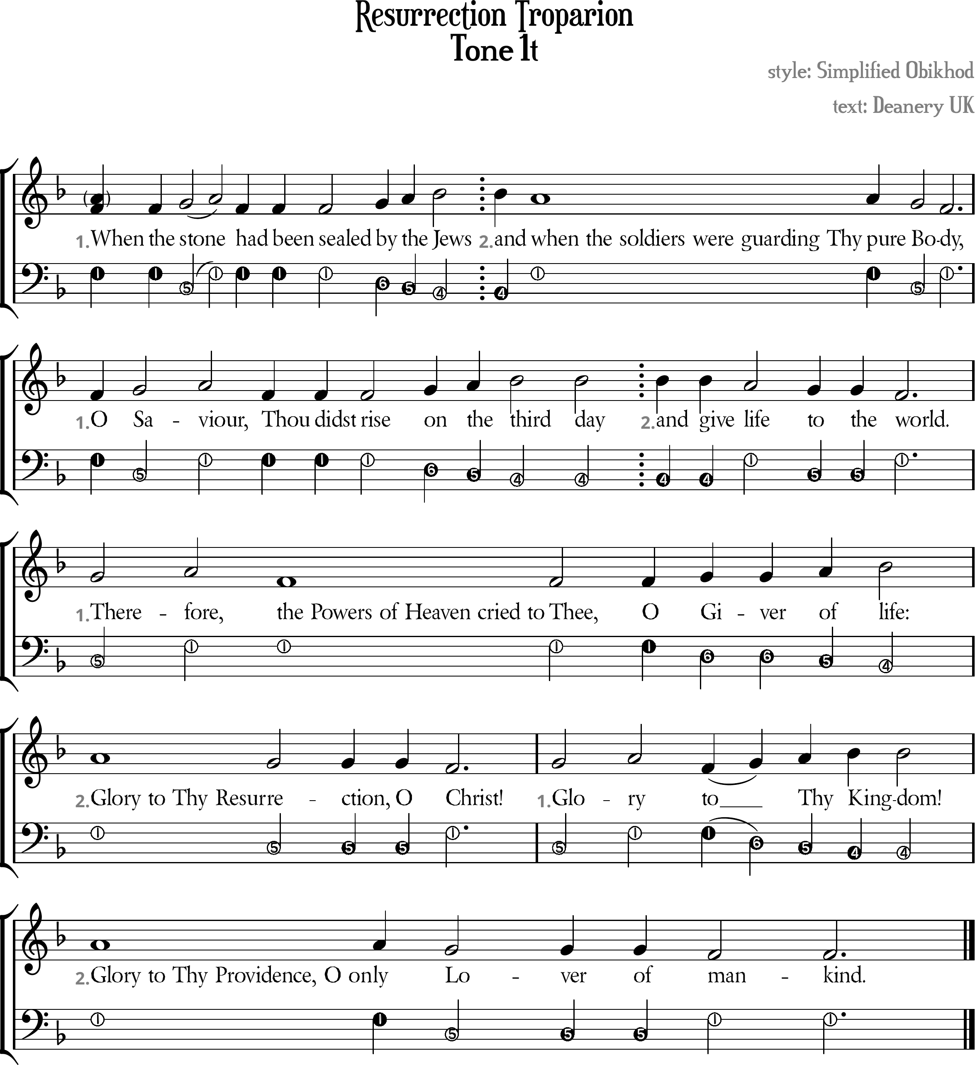
Compiled by V. Mastoridis,
by the prayers of Sts Etheldreda of Ely & Sophrony of Essex;
April 2026

Resurrection Troparion Tone 1t
[ Tone Pattern ]
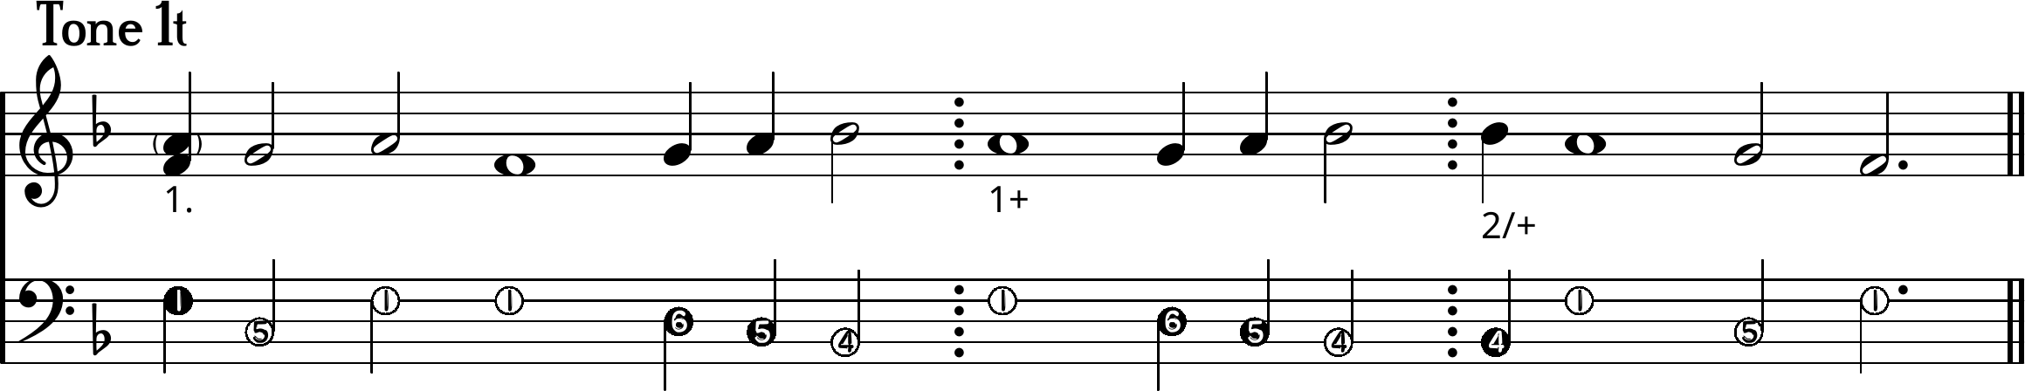
1. When the /sto/~ne \\had been sealed /by /the /Jews
2. And \when the soldiers were guarding Thy pure \Bo\dy,
1. O /Sa/viour, \\Thou didst rise /on /the /third day
2. And give \life \to the \world.
1. /There/fore, \\the Powers of Heaven cried to Thee,
O /Giver /of /life:
2. \Glory to Thy Resur \rection, O \Christ!
1. /Glo/ry \\to/~ /Thy /Kingdom!
+ \Glory to Thy Providence, O only \Lover of \mankind.

[ Ison ]
I. ¹When the ⁵sto¹~ne had been sealed ⁶by ⁵the ⁴Jews
II. ⁴And ¹when the soldiers were guarding Thy pure ⁵Bo¹dy,
I. ¹O ⁵Sa¹viour, Thou didst rise ⁶on ⁵the ⁴third day
II. ⁴And give ¹life ⁵to the ¹world.
I. ⁵There¹fore, the Powers of Heaven cried to Thee,
O ⁶Giver ⁵of ⁴life:
II. ¹Glory to Thy Resur⁵rection, O ¹Christ!
I. ⁵Glo¹ry to⁶~ ⁵Thy ⁴Kingdom!
+ ¹Glory to Thy Providence, O only ⁵Lover of ¹mankind.

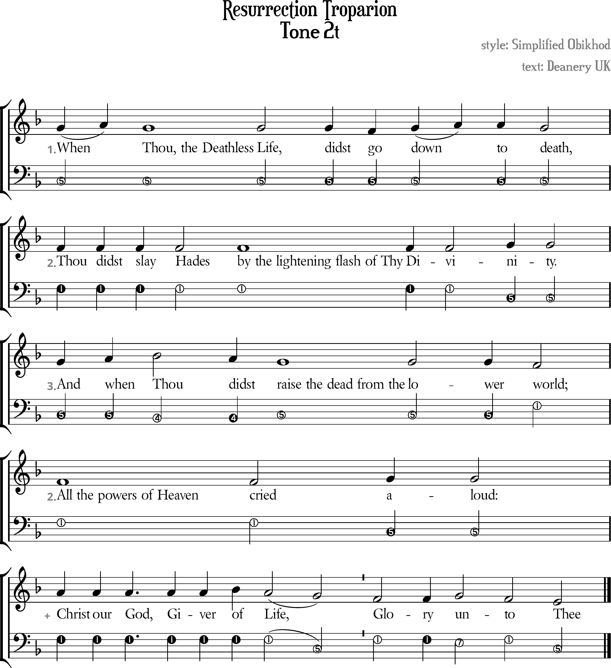

Resurrection Troparion Tone 2t
[ Tone Pattern ]
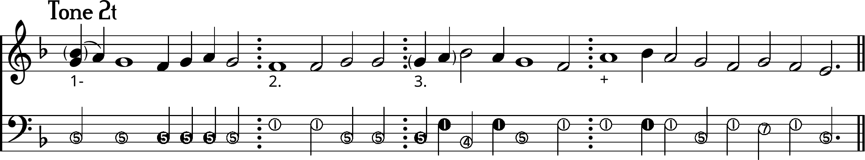
1- /Whe/~n \Thou, the Deathless Life,
didst \go /do/~wn to \death
2. \Thou didst slay Hades by the lightening flash of Thy Divi/nity.
3. And /when /Thou \didst
\raise the dead from the lower \world,
2. All the powers of Heaven cried /aloud:
+ /Christ our God, Giver /of \Li\~fe,
\Glory /un\to \Thee.

[ Ison ]
I- ⁵When Thou, the Deathless Life, didst go down to death,
II. ¹Thou didst slay Hades by the lightening flash of Thy Divi⁵nity.
III. ⁴And when ⁴Thou didst
⁵raise the dead from the lower ¹world,
II. ¹All the powers of Heaven cried ⁵aloud:
+ ¹Christ our God, Giver of Li⁵~fe, ¹Glory ⁷un¹to ⁵Thee.
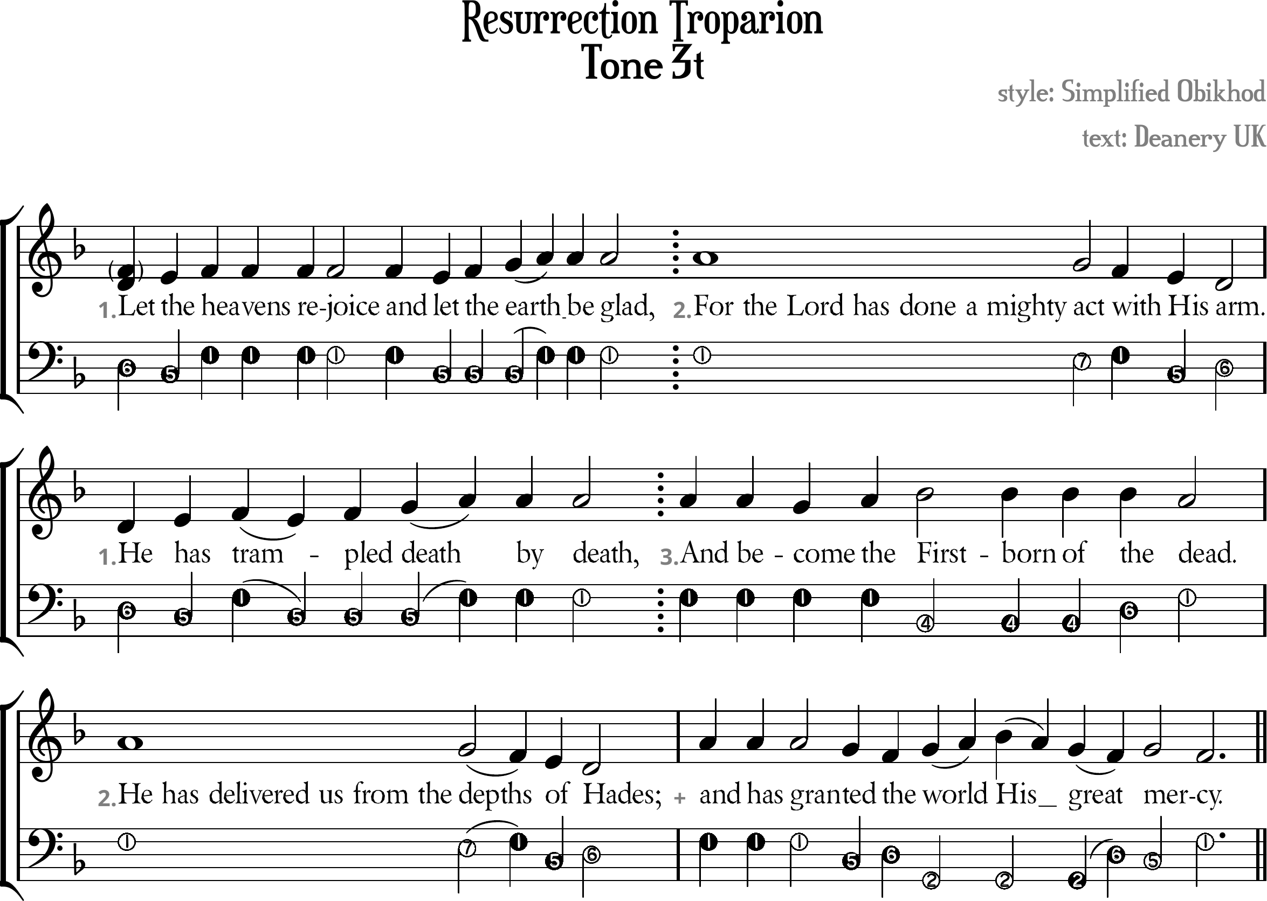

Resurrection Troparion Tone 3t
[ Tone Pattern ]
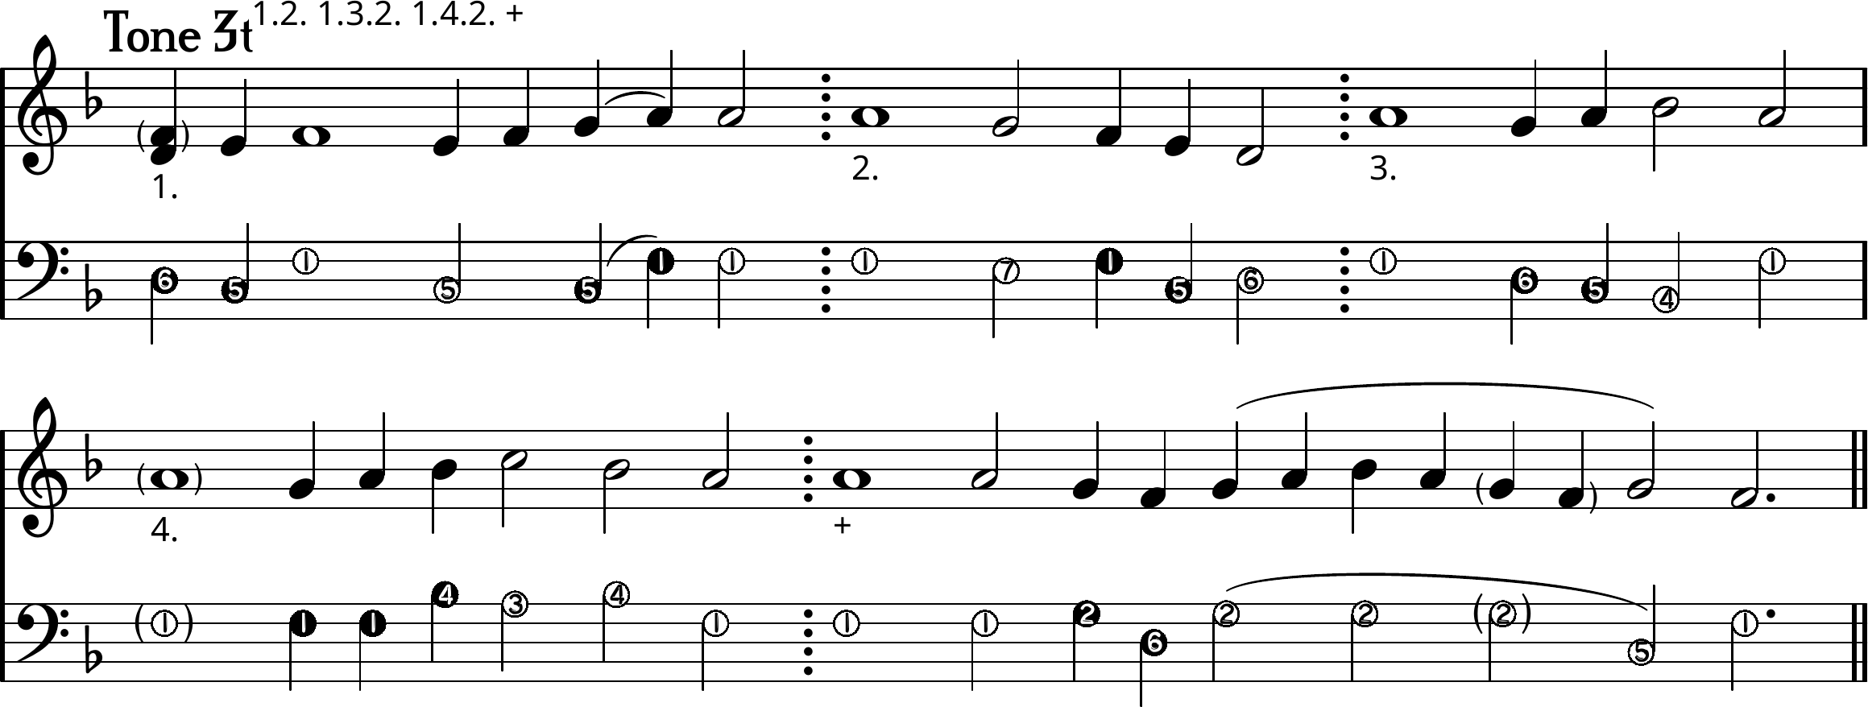
1. \\Let /the /heavens rejoice
and \let /the /ea/~rth be glad,
2. For the Lord has done a mighty \act \with \His \arm.
1. He /has /tra\~m/pled /dea/~th by death,
3. And be\come /the /Firstborn of the \dead.
2. He has delivered us from the \de\~pths \of \Hades;
+ |/And has gran\ted \the /wo/~rld
/Hi\~s \grea\~t /mer\cy.

[ Ison ]
I. ⁶Let ⁵the ¹heavens rejoice and ⁵let the ea¹~rth be glad,
II. ¹For the Lord has done a mighty ⁷act ¹with ⁵His ⁶arm.
I. ⁶He ⁵has ¹tra⁵~mpled dea¹~th by death,
III. ¹And become the ⁴Firstborn of ⁶the ¹dead.
II. ¹He has delivered us from the ⁷de¹~pths ⁵of ⁶Hades;
+ ¹And has gran⁵ted ⁶the ²world His grea⁶~t ⁵mer¹cy.

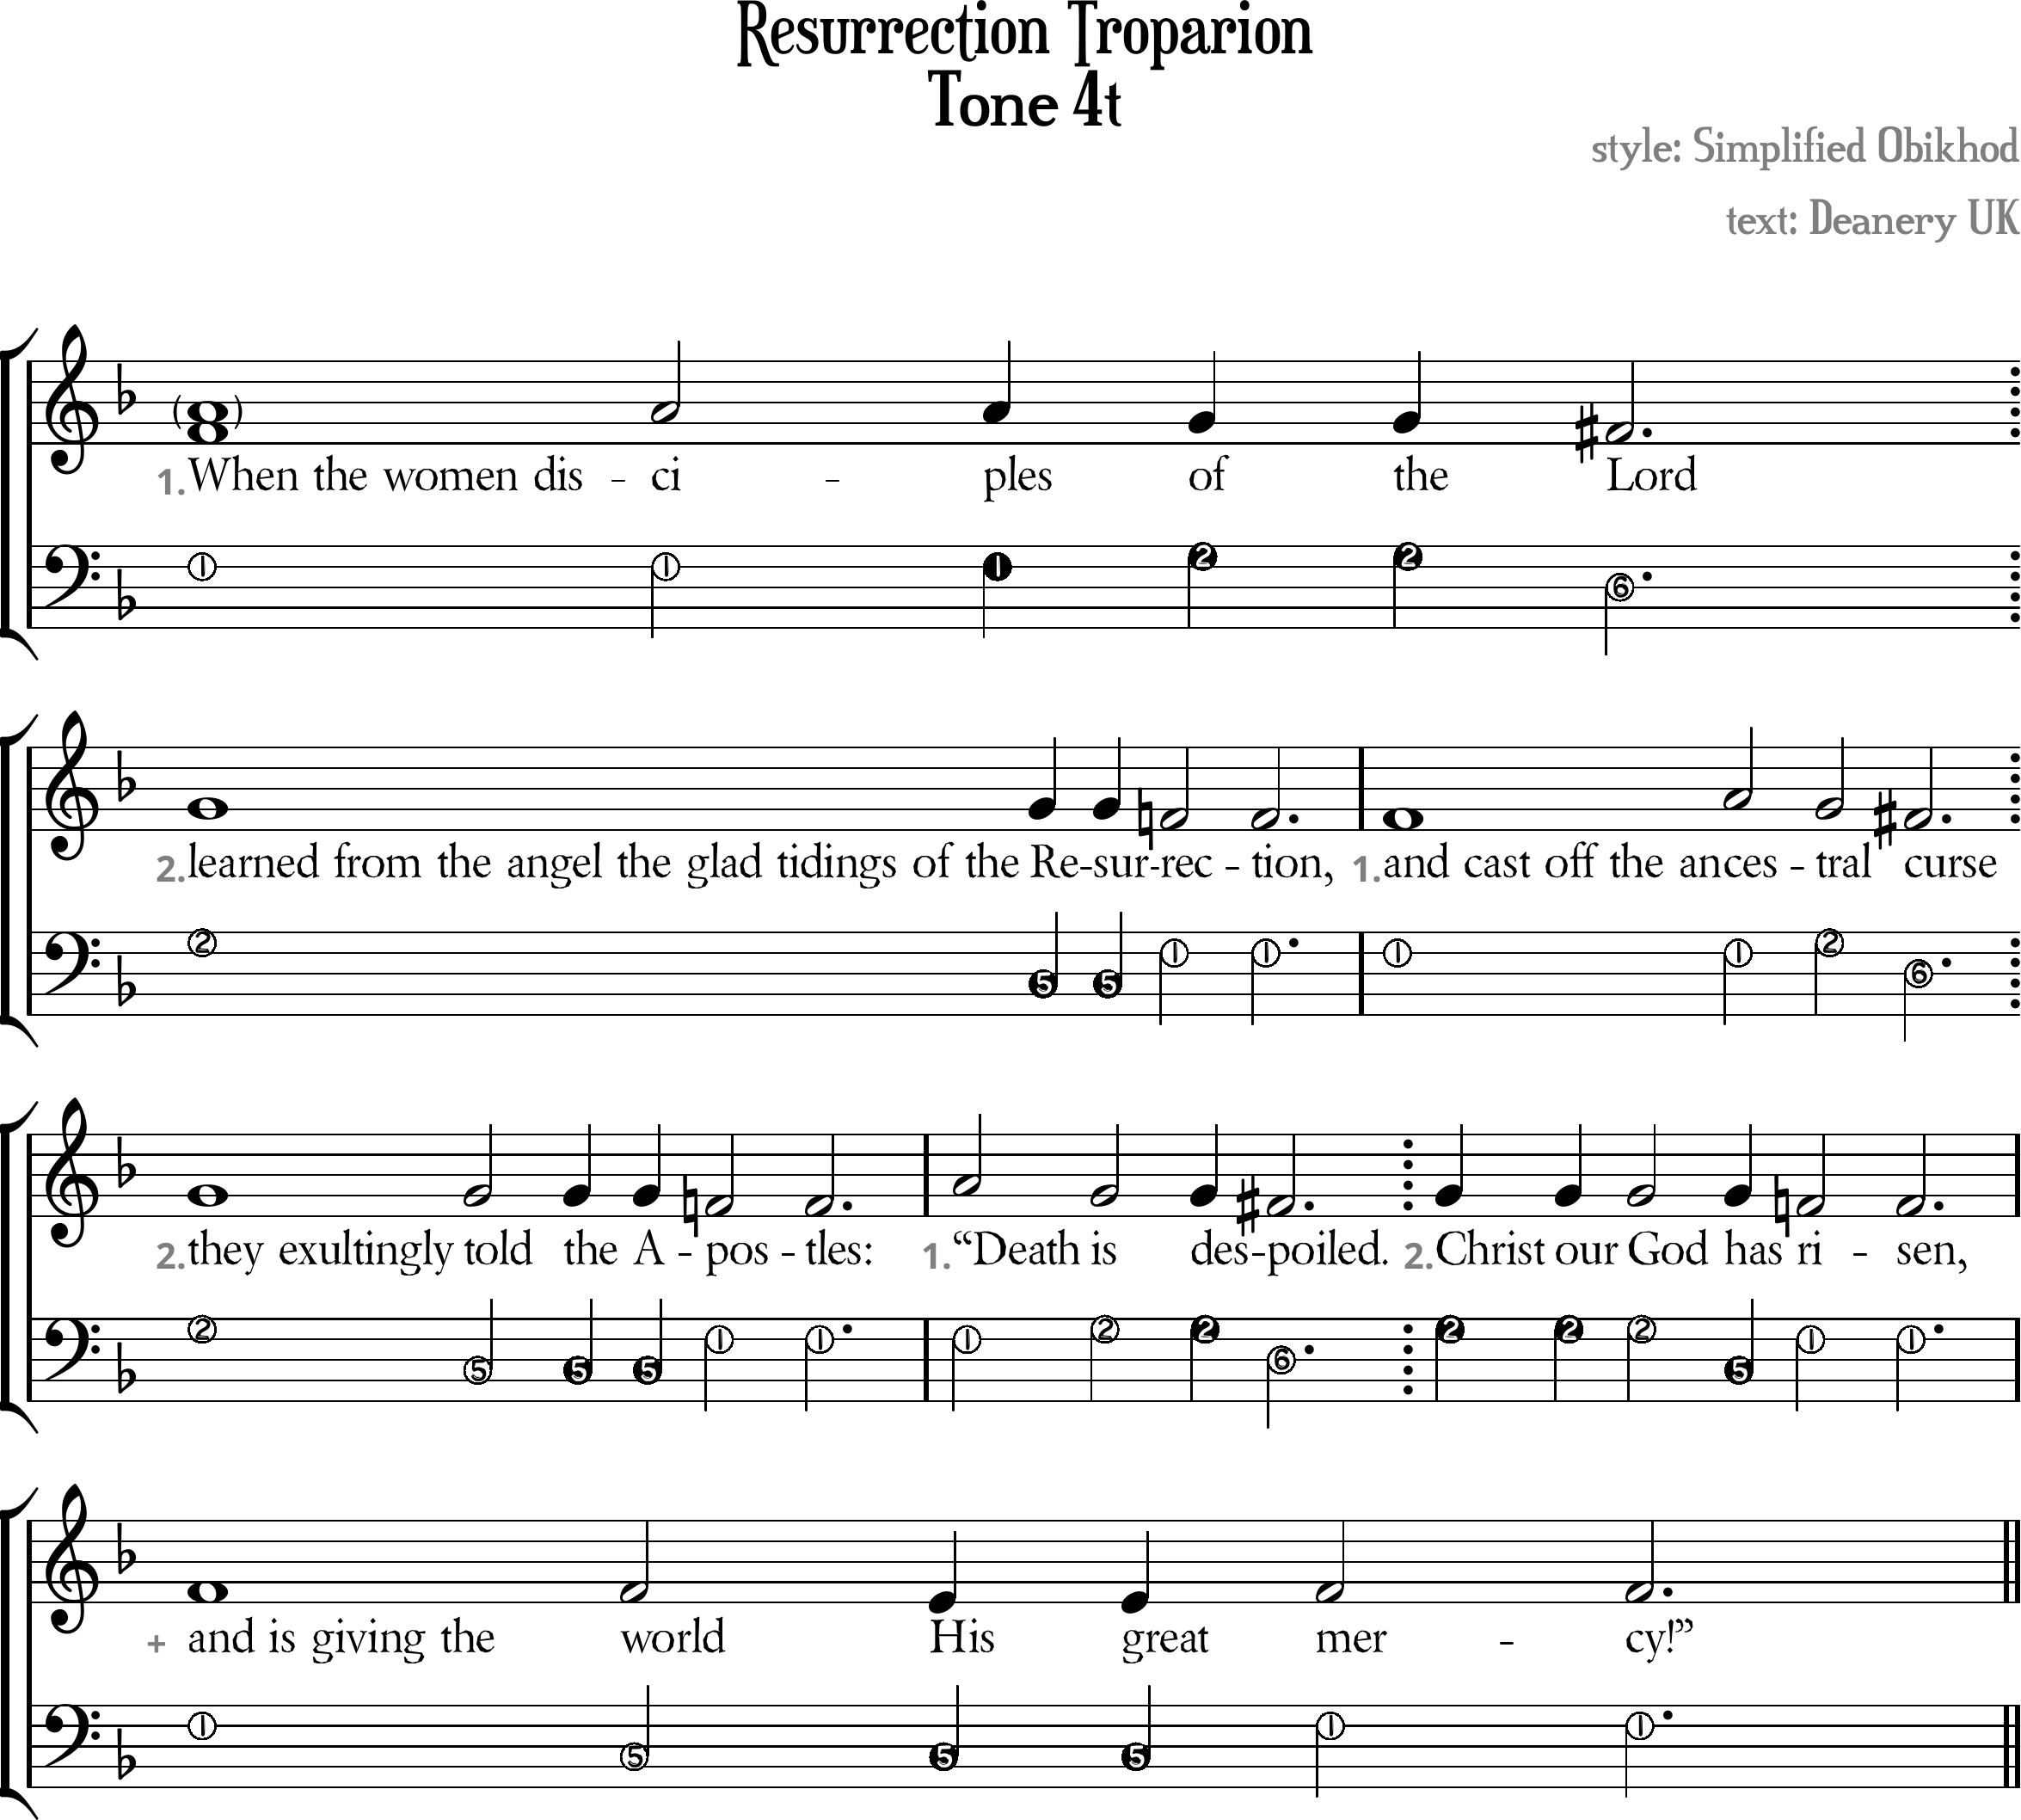

Resurrection Troparion Tone 4t
[ Tone Pattern ]
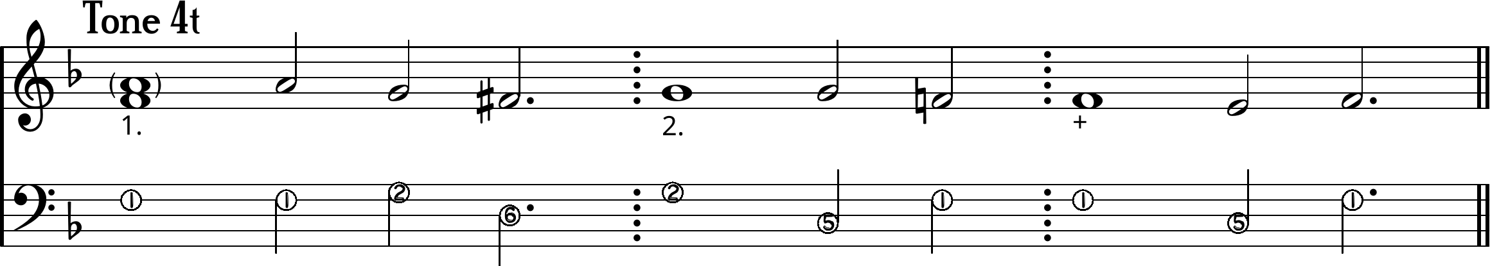
1. When the women dis//ciples \of the \♯Lord
2. /Learned from the angel the glad tidings of the
Resur\rection,
1. And cast off the an//ces\tral \♯curse
2. /They exultingly told the A\postles:
1. //“Death is des\♯poiled.
2. /Christ our God has \risen,
+ And is giving the world \His great /mercy!”

[ Ison ]
I. ¹When the women disciples ²of the ⁶Lord
II. ²Learned from the angel the glad tidings of the
⁵Resur¹rection,
I. ¹And cast off the ances²tral ⁶curse
II. ²They exultingly ⁵told the A¹postles:
I. ¹“Death ²is des⁶poiled.
II. ²Christ our ⁵God has ¹risen,
+ ¹And is giving the world ⁵His great ¹mercy!”

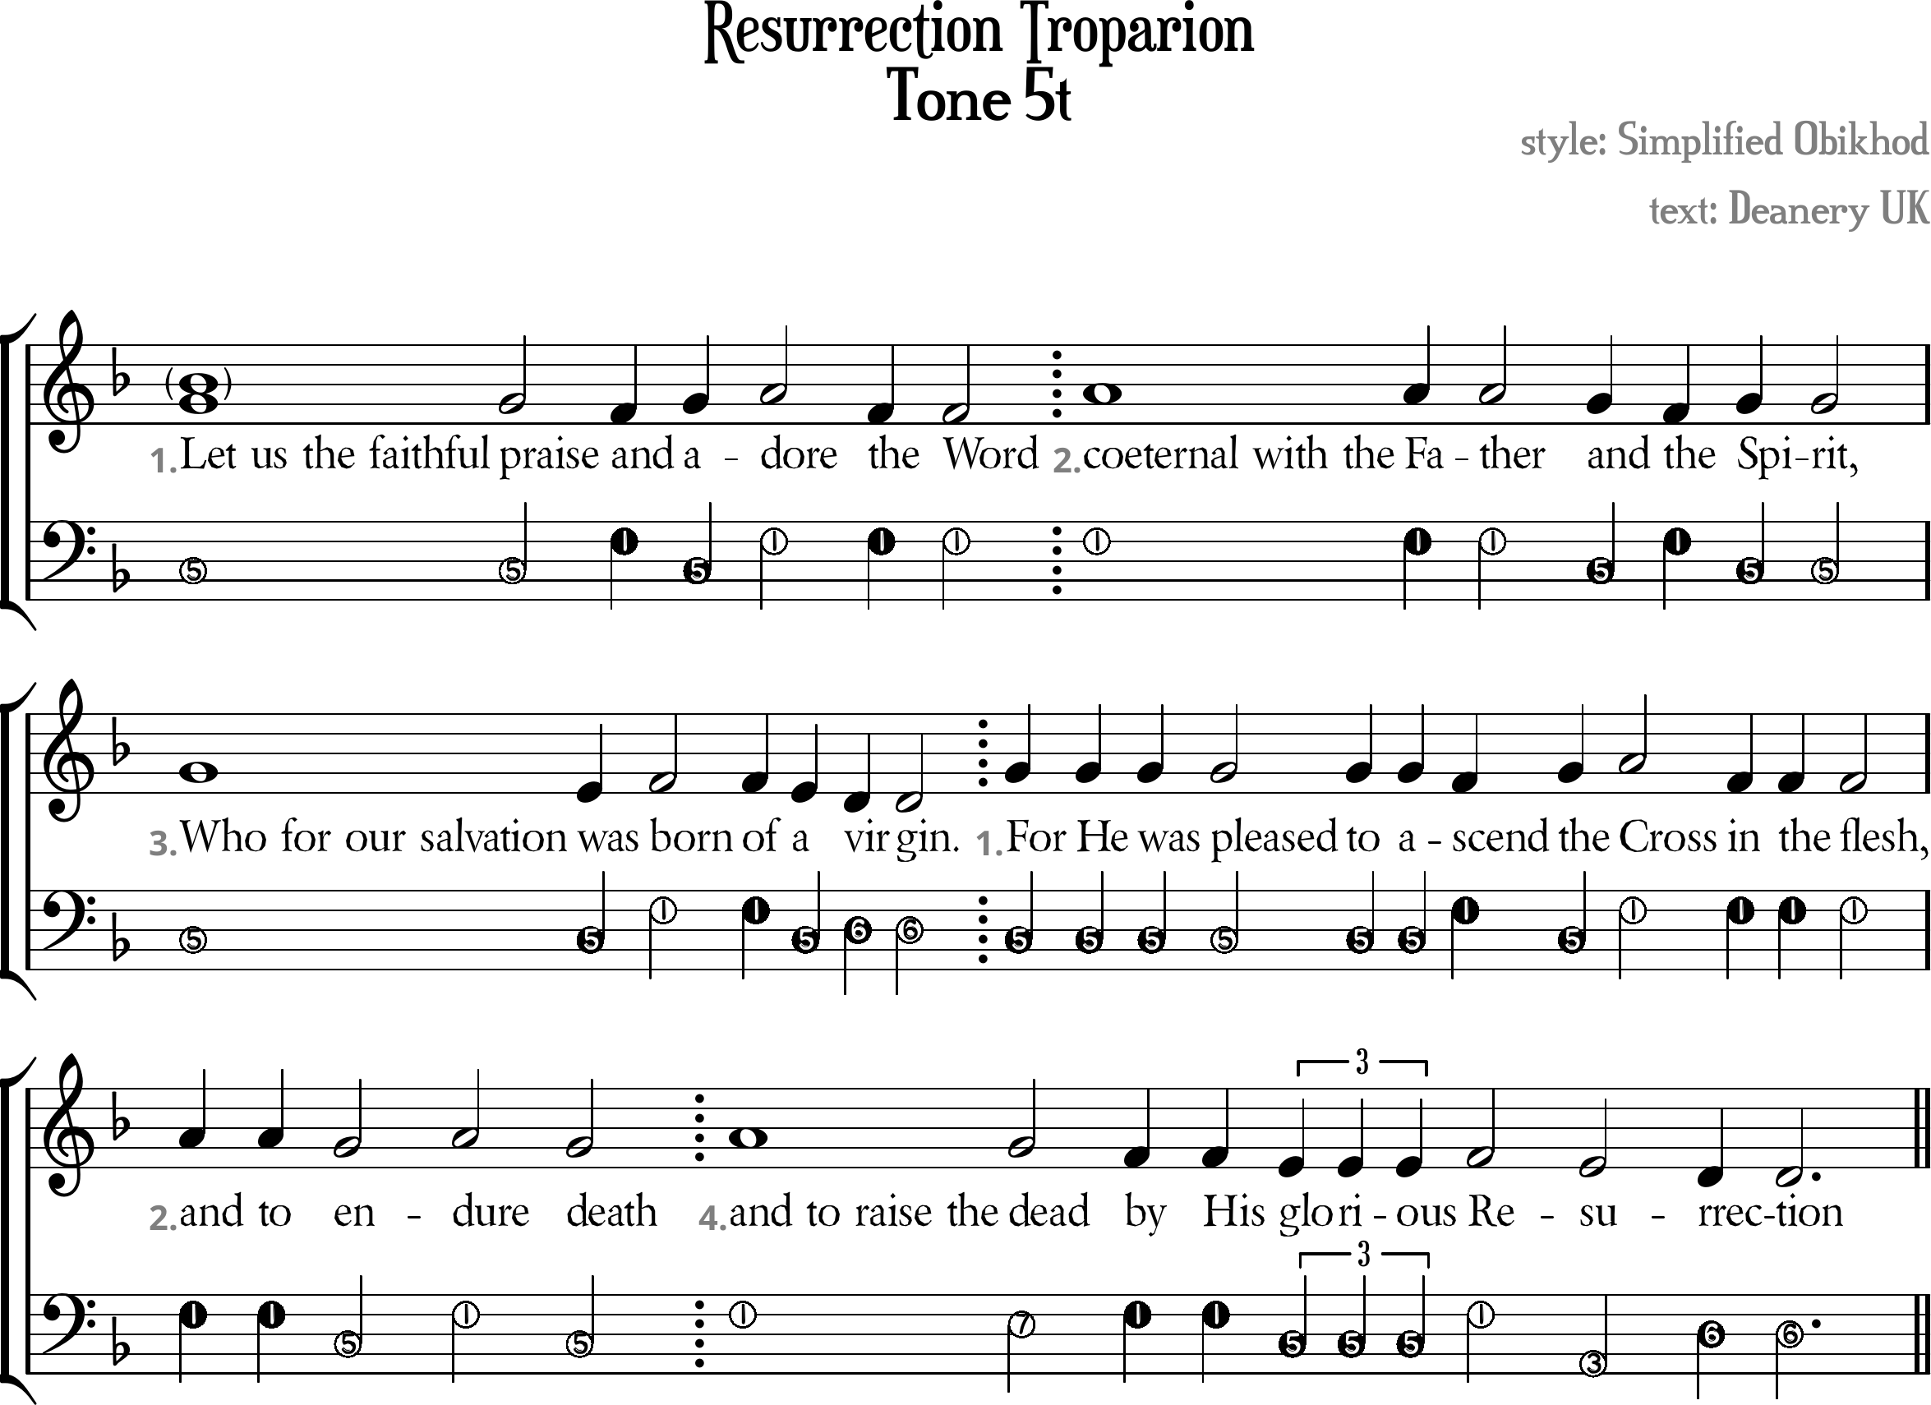

Resurrection Troparion Tone 5t
[ Tone Pattern ]
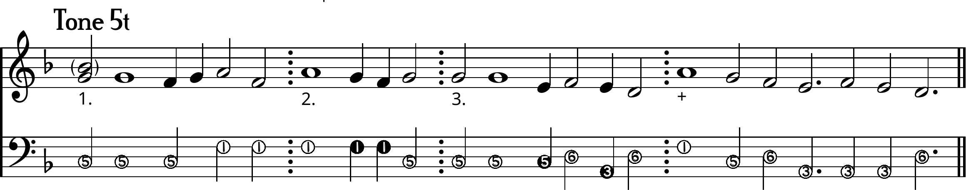
1. /Let us the faithful praise \and /a/dore \\the Word
2. //coeternal with the Father \and \the /Spirit,
3. Who for our salvation \\was /born \of \a \virgin.
1. ///For He was pleasedto a\scend /the
/Cross \\in the flesh,
2. //and to \en/dure \death
+ /and to raise the \dead
\by His \glorious /Re\sur\rection

[ Ison ]
I. ⁵Let us the faithful praise ¹and ⁵a¹dore the Word
II. ¹Coeternal with the Father ⁵and ¹the ⁵Spirit,
III. ⁵Who for our salvation was ¹born of ⁵a ⁶virgin.
I. ⁵For He was pleased
to a¹scend ⁵the ¹Cross in the flesh,
II. ¹ And to ⁵en¹dure ⁵death
+ ¹And to raise the ⁷dead ¹by His ⁵glorious
³Resur⁶rection

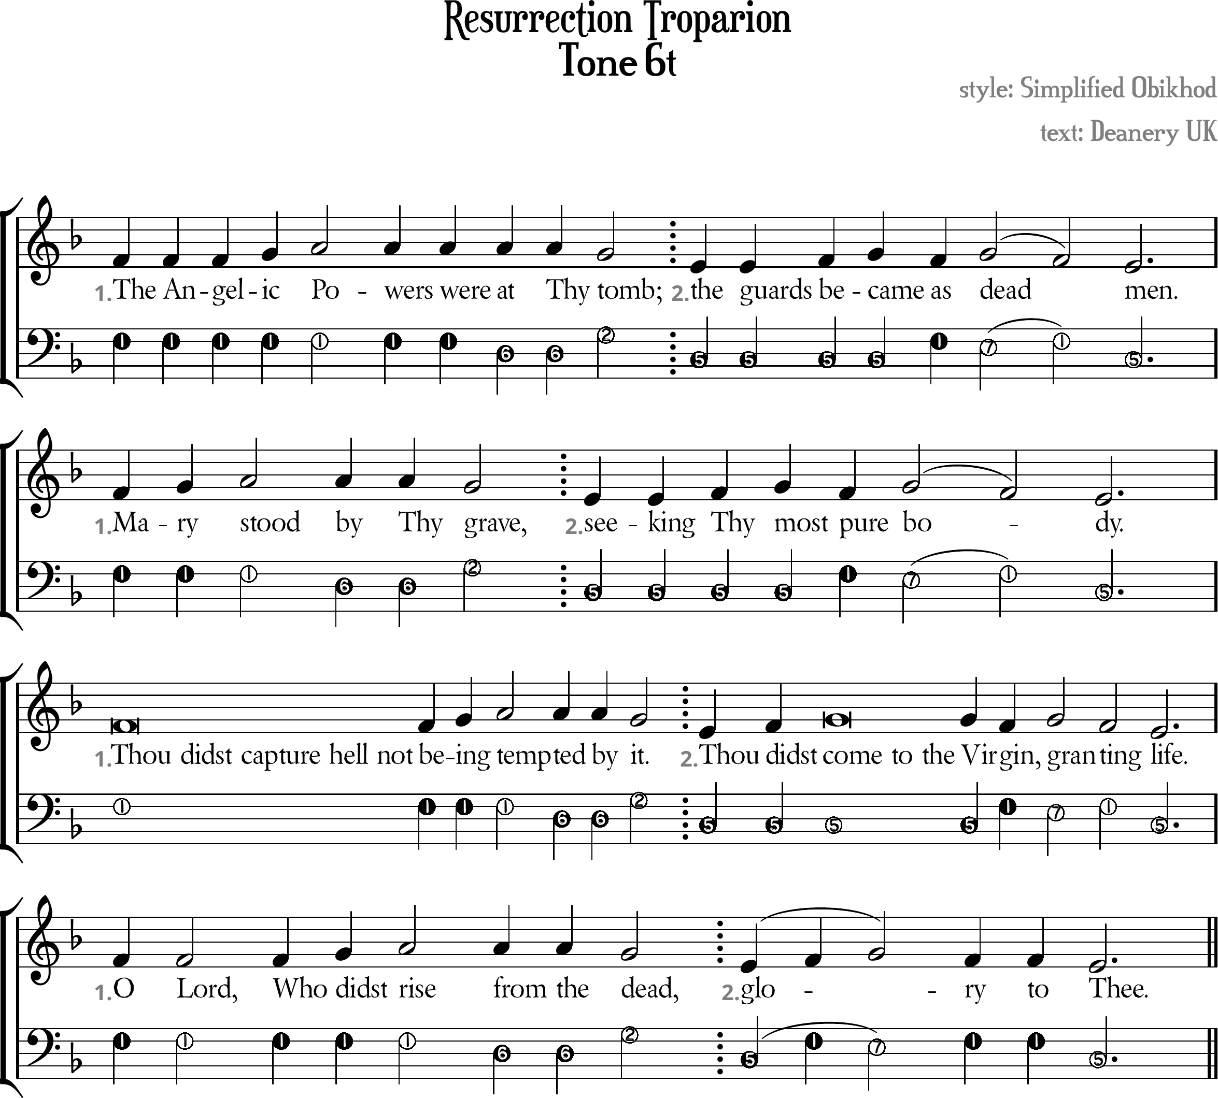

Resurrection Troparion Tone 6t
[ Melody/Ison Template ]
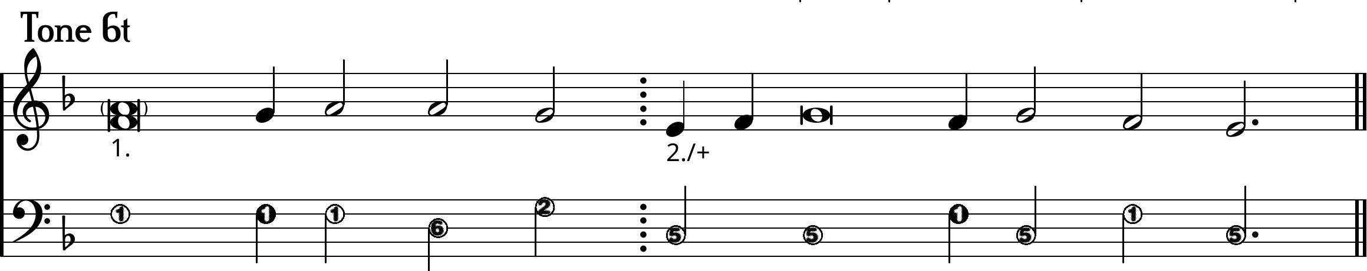
1. The Ange/lic Powers were at Thy \tomb;
2. \\The guards be/came \as /dea\~d \men.
1. /Ma/ry /stood by Thy \grave,
2. \\Seeking /Thy /most \pure /bo\~\dy.
1. /Thou didst capture hell not bei/~ng /tempted by \it.
2. \\Thou /didst /come to the Vir\gin, /gran\ting \life.
1. O Lord, Who /didst /rise from the \dead,
+ \\Glo/~/~\ry to \Thee.

[ ison ]
I. ¹The Angelic Powers were ⁶at Thy ²tomb;
II. ⁵The guards became ¹as ⁷dea¹~d ⁵men.
I. ¹Mary stood ⁶by Thy ²grave,
II. ⁵Seeking Thy most ¹pure ⁷bo¹~⁵dy.
I. ¹Thou didst capture hell not bei~ng temp⁶ted by ²it.
II. ⁵Thou didst come to the Vir¹gin, ⁷gran¹ting ⁵life.
I. ¹O Lord, Who didst rise ⁶from the ²dead,
+ ⁵Glo¹~⁷~¹ry to ⁵Thee.

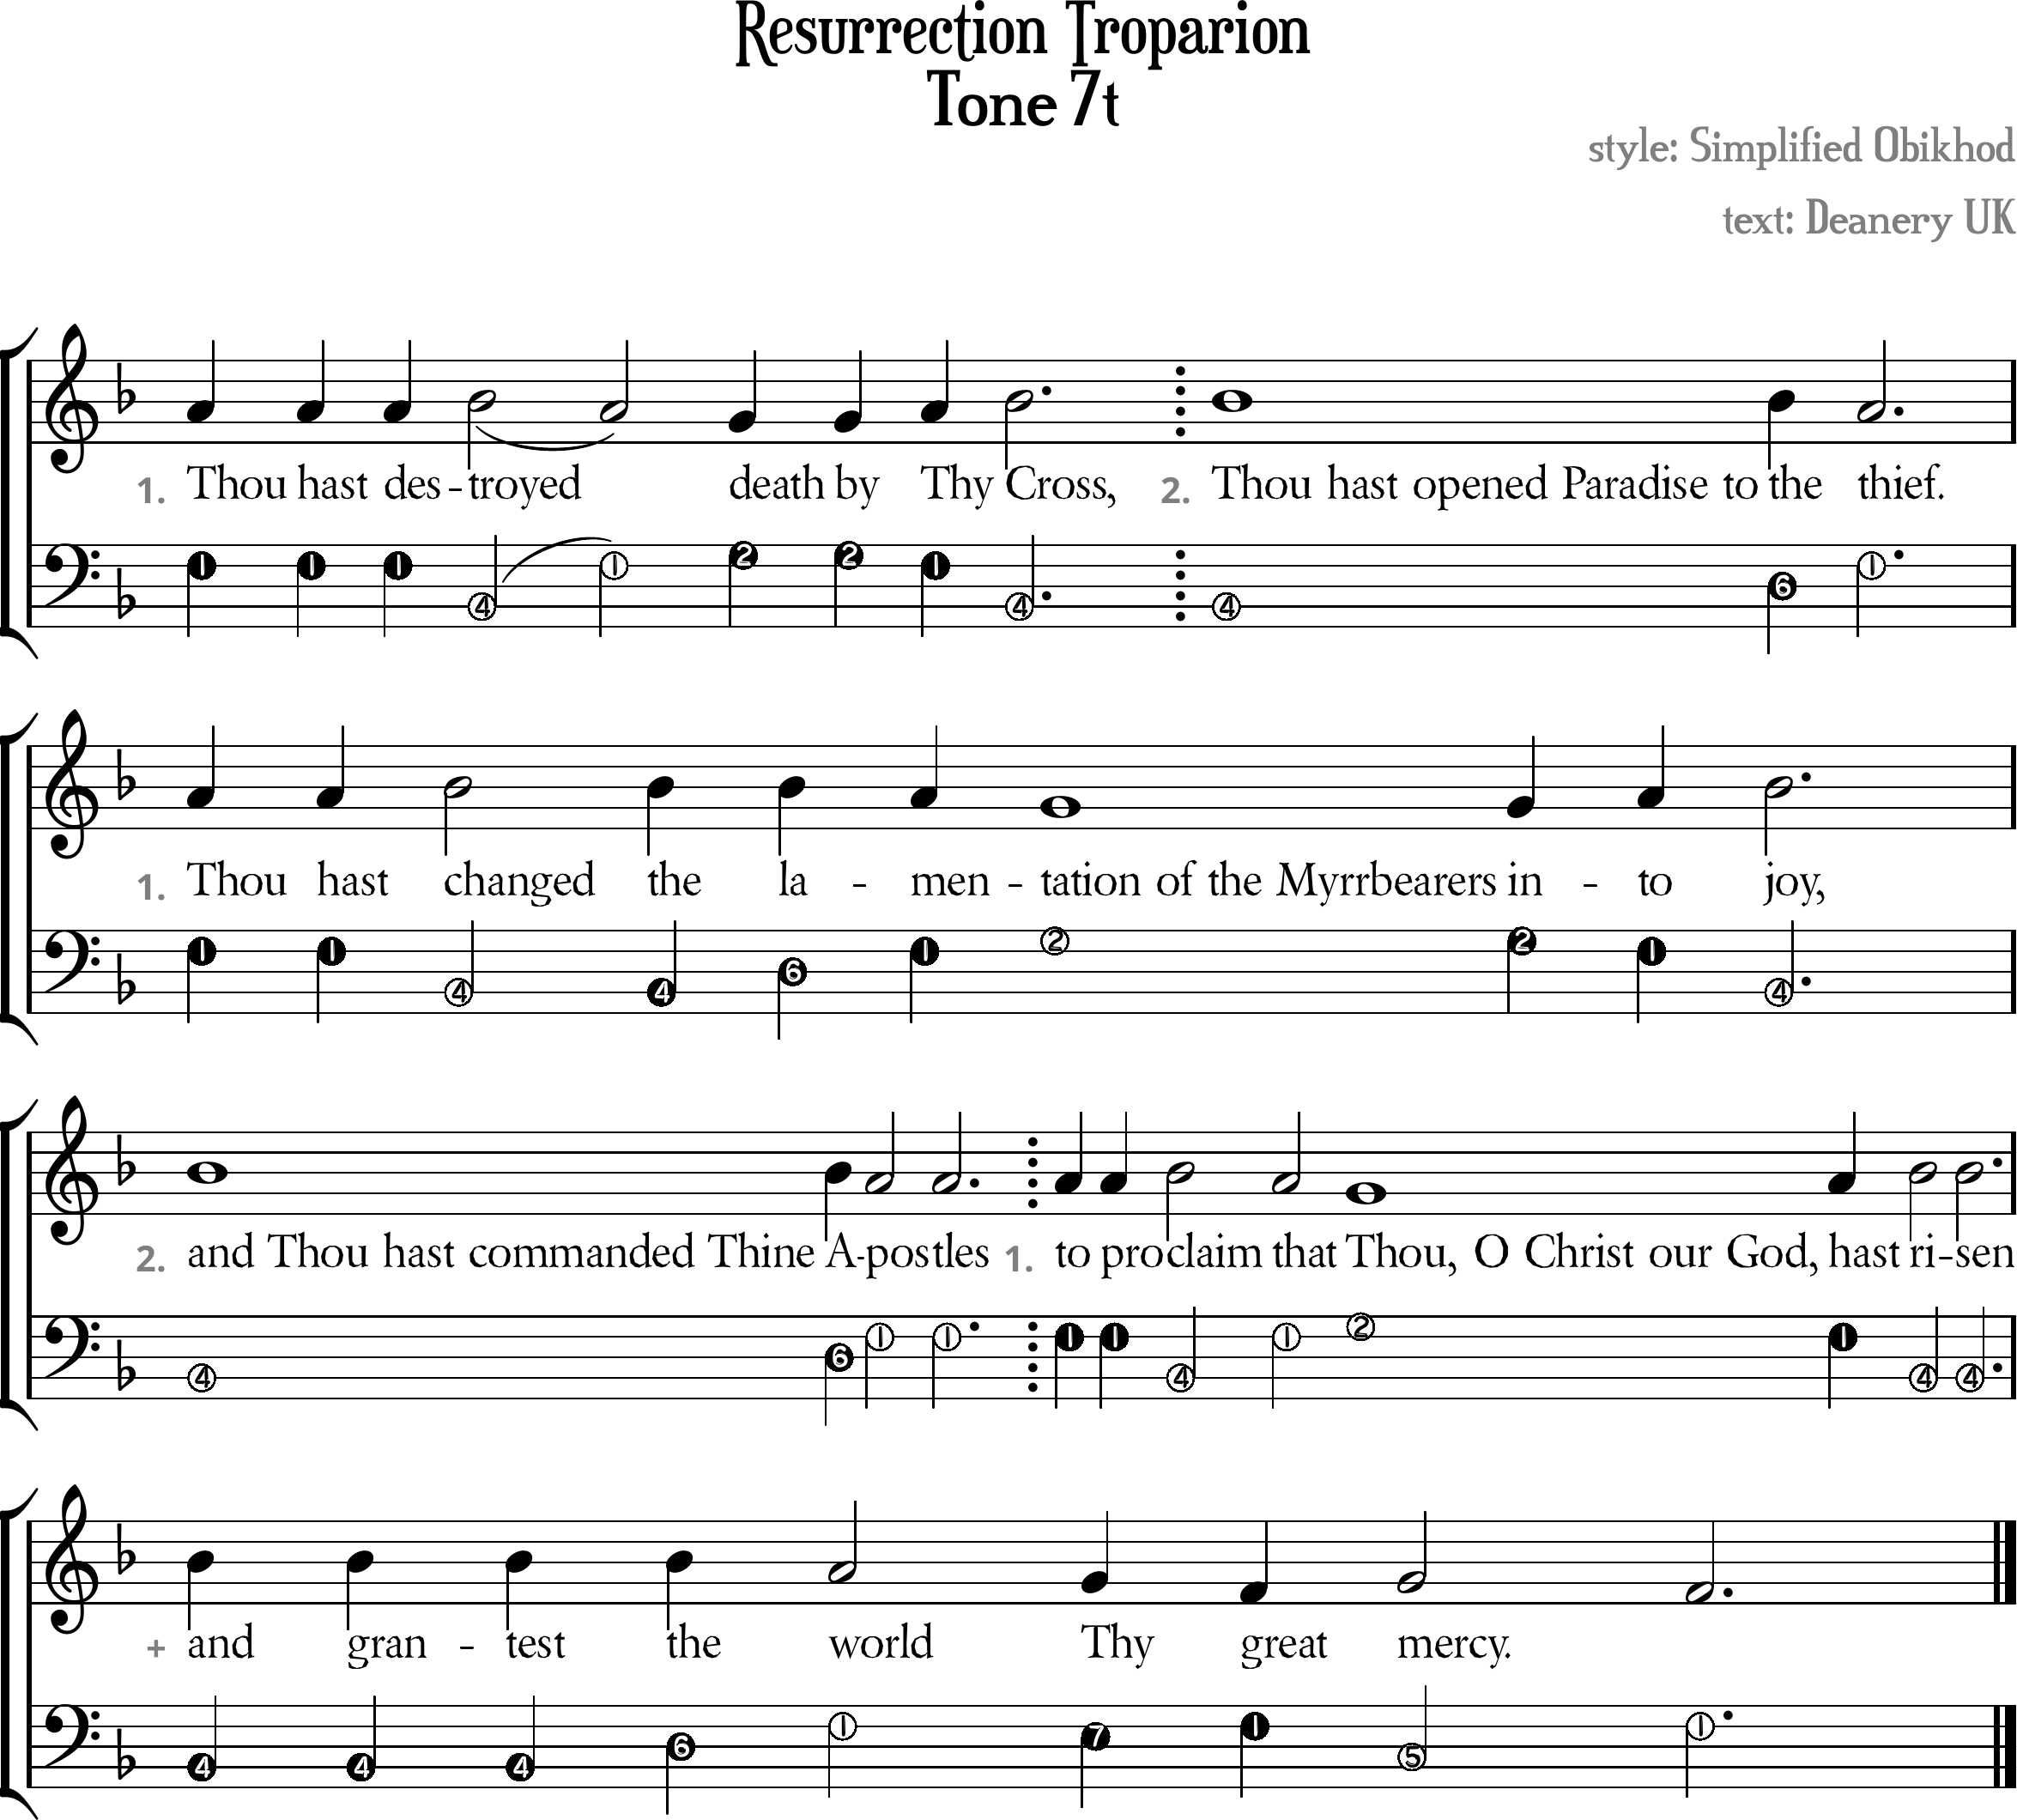

Resurrection Troparion Tone 7t
[ Tone Pattern ]
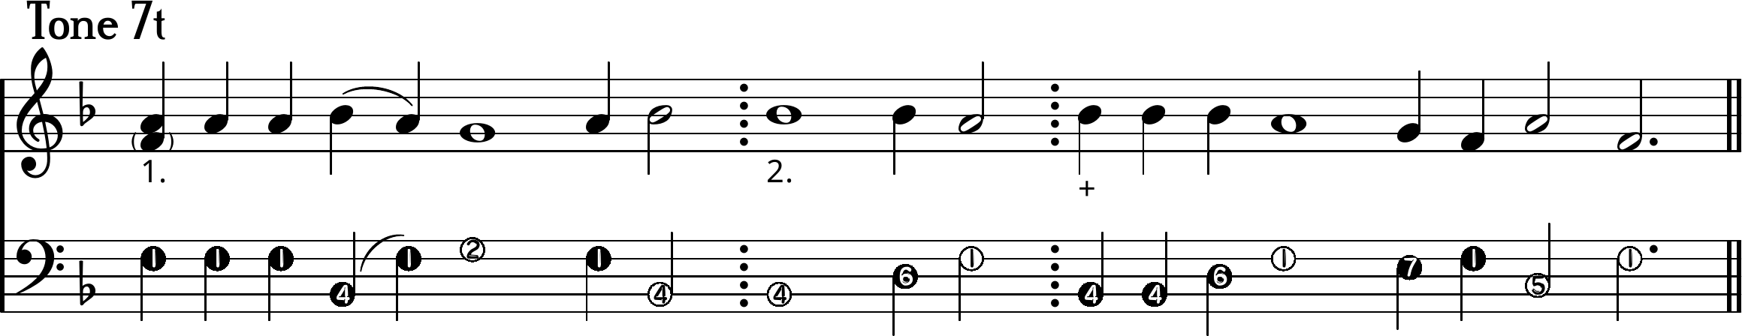
1. //Thou hast des/tro\~yed \death by /Thy /Cross,
2. Thou hast opened Paradise to the \thief.
1. Thou hast /changed the lamen\\tation of the
Myrrbearers in/to /joy,
2. And Thou hast commanded Thine A\postles
1. To pro/claim \that \Thou, O Christ our God, hast /risen
+ And grantest the \world \Thy \great /mer\cy.

[ Ison ]
I. ¹Thou hast des⁴tro¹~yed ²death by ¹Thy ⁴Cross,
II. Thou hast opened Paradise to ⁶the ¹thief.
I. Thou hast ⁴changed the ⁶la¹men²tation of the
Myrrbearers in¹to ⁴joy,
II. And Thou hast commanded Thine ⁶A¹postles
I. To pro⁴claim ¹that ²Thou, O Christ our God, ¹hast ⁴risen
+ And grantest ⁶the ¹world ⁷Thy ¹great ⁵mer¹cy.

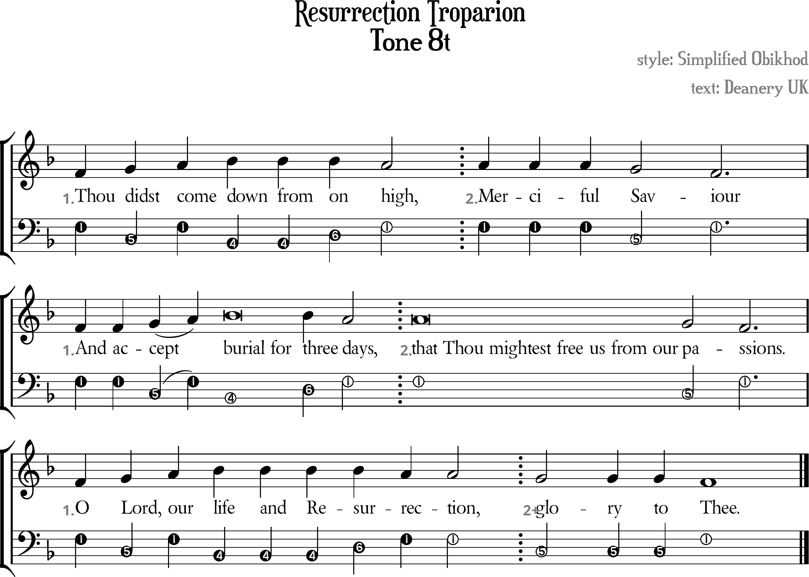

Resurrection Troparion Tone 8t
[ Tone Pattern ]
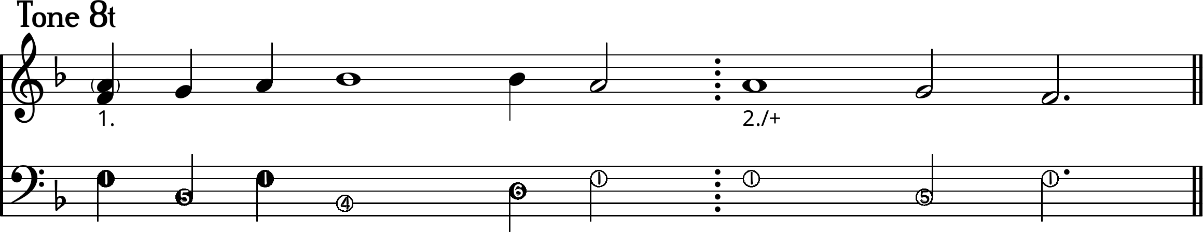
1. Thou /didst /come /down from on \high,
2. Merciful \Sa\viour
1. And ac/ce/~pt /burial for three \days,
2. That Thou mightest free us from our \pas\sions.
1. O /Lord, /our /life and Resur\rection,
+ \\Glory to \Thee.

[ Ison ]
I. ¹Thou ⁵didst ¹come ⁴down from ⁶on ¹high,
II. Merciful ⁵Sa¹viour
I. And ac⁵ce¹~pt ⁴burial for ⁶three ¹days,
II. That Thou mightest free us from our ⁵pas¹sions.
I. ¹O ⁵Lord, ¹our ⁴life and Re⁶sur¹rection,
+ ⁵Glory to ¹Thee.

