KONTAKIA
Tones 1-8
Simplified Obikhod
Melody & Ison
Standard & Pointed Notation
Tone “t” refers to a Troparion Melody Pattern

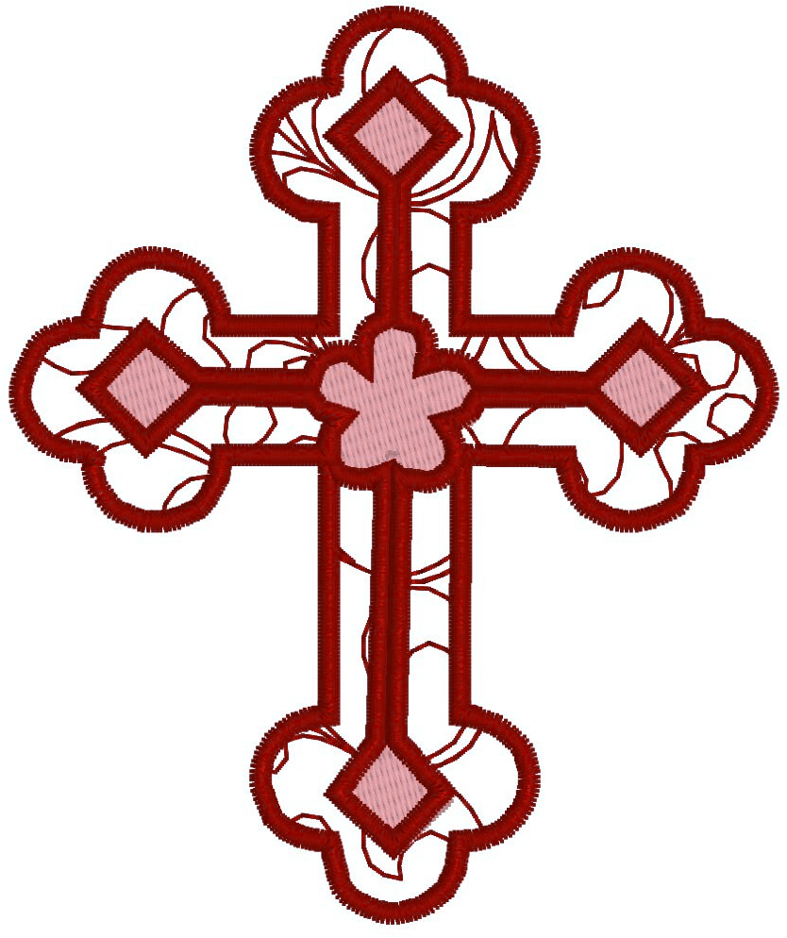
Compiled by V. Mastoridis,
by the prayers of Sts Etheldreda of Ely & Sophrony of Essex;
April 202⁶
Digital Pointed Notation Guide

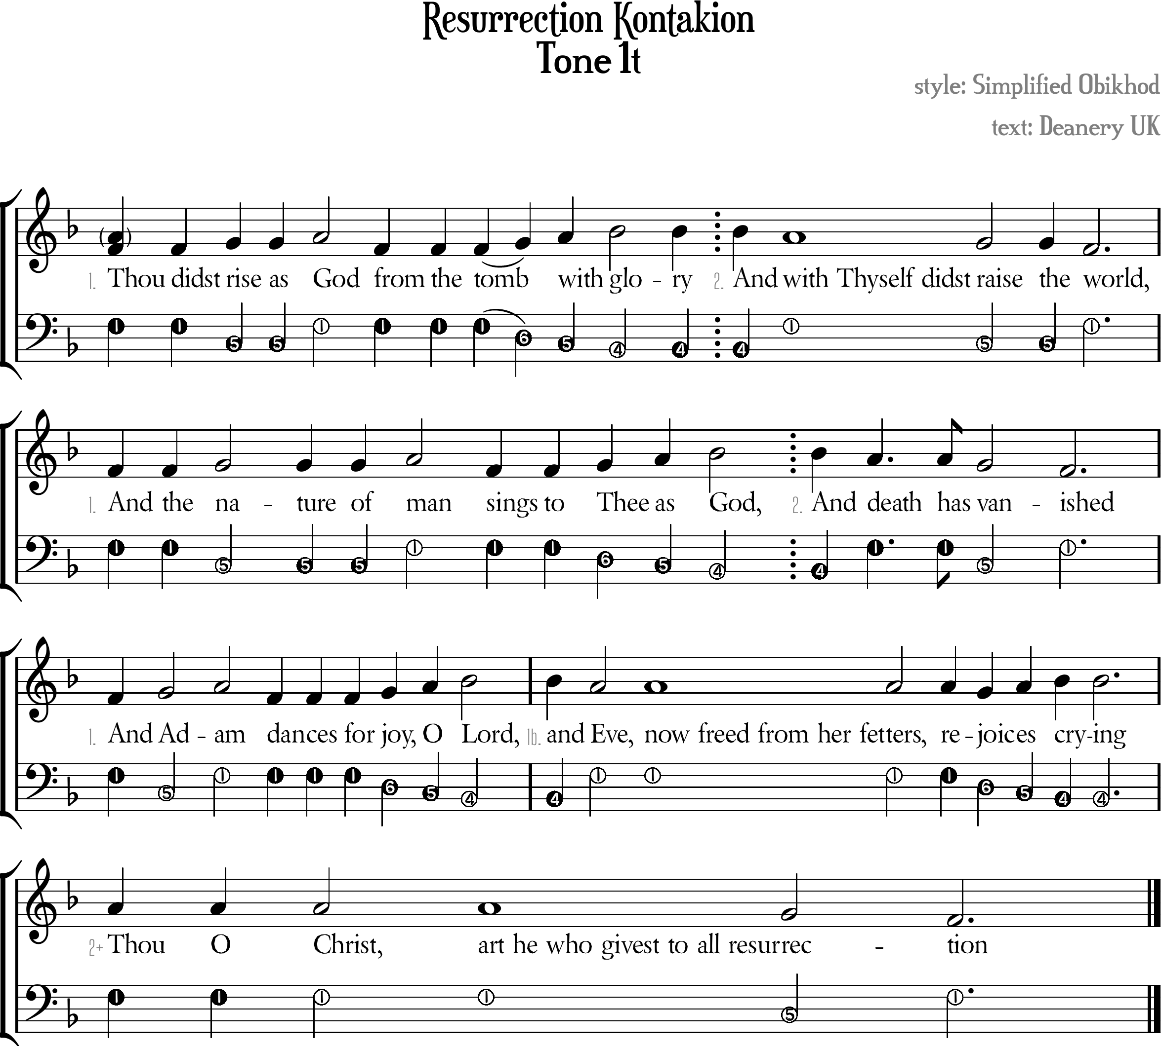

Resurrection Kontakion Tone 1t
[ Tone Pattern ]
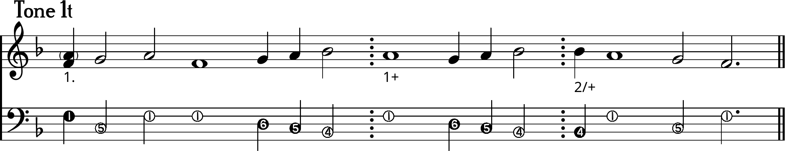
1. Thou didst /rise as /God \\from the to/~mb /with /glory
2. And \with Thyself didst \raise the \world,
1. And the /nature of /man \\sings to /Thee /as /God,
2. And \death has \va\nished
1. And /A/dam \\dances for /joy, /O /Lord,
1+ And \Eve, now freed from her fetters, re\joi/ces /crying
+ \Thou O Christ, art he who givest to all resur\re\ction

[ Ison ]
I. ¹Thou didst ⁵rise as ¹God from the to⁴~mb ⁵with ⁶glory
II. And ¹with Thyself didst ⁵raise the ¹world,
I. And the ⁵nature of ¹man sings to ⁴Thee ⁵as ⁴God,
II. And ¹death has ⁵va¹nished
I. And ⁵A¹dam dances for ⁶joy, ⁵O ⁴Lord,
I+ And ¹Eve, now freed from her fetters, re⁶joi⁵ces ⁴crying
+ ¹Thou O Christ, art he who givest to all resur⁵re¹ction

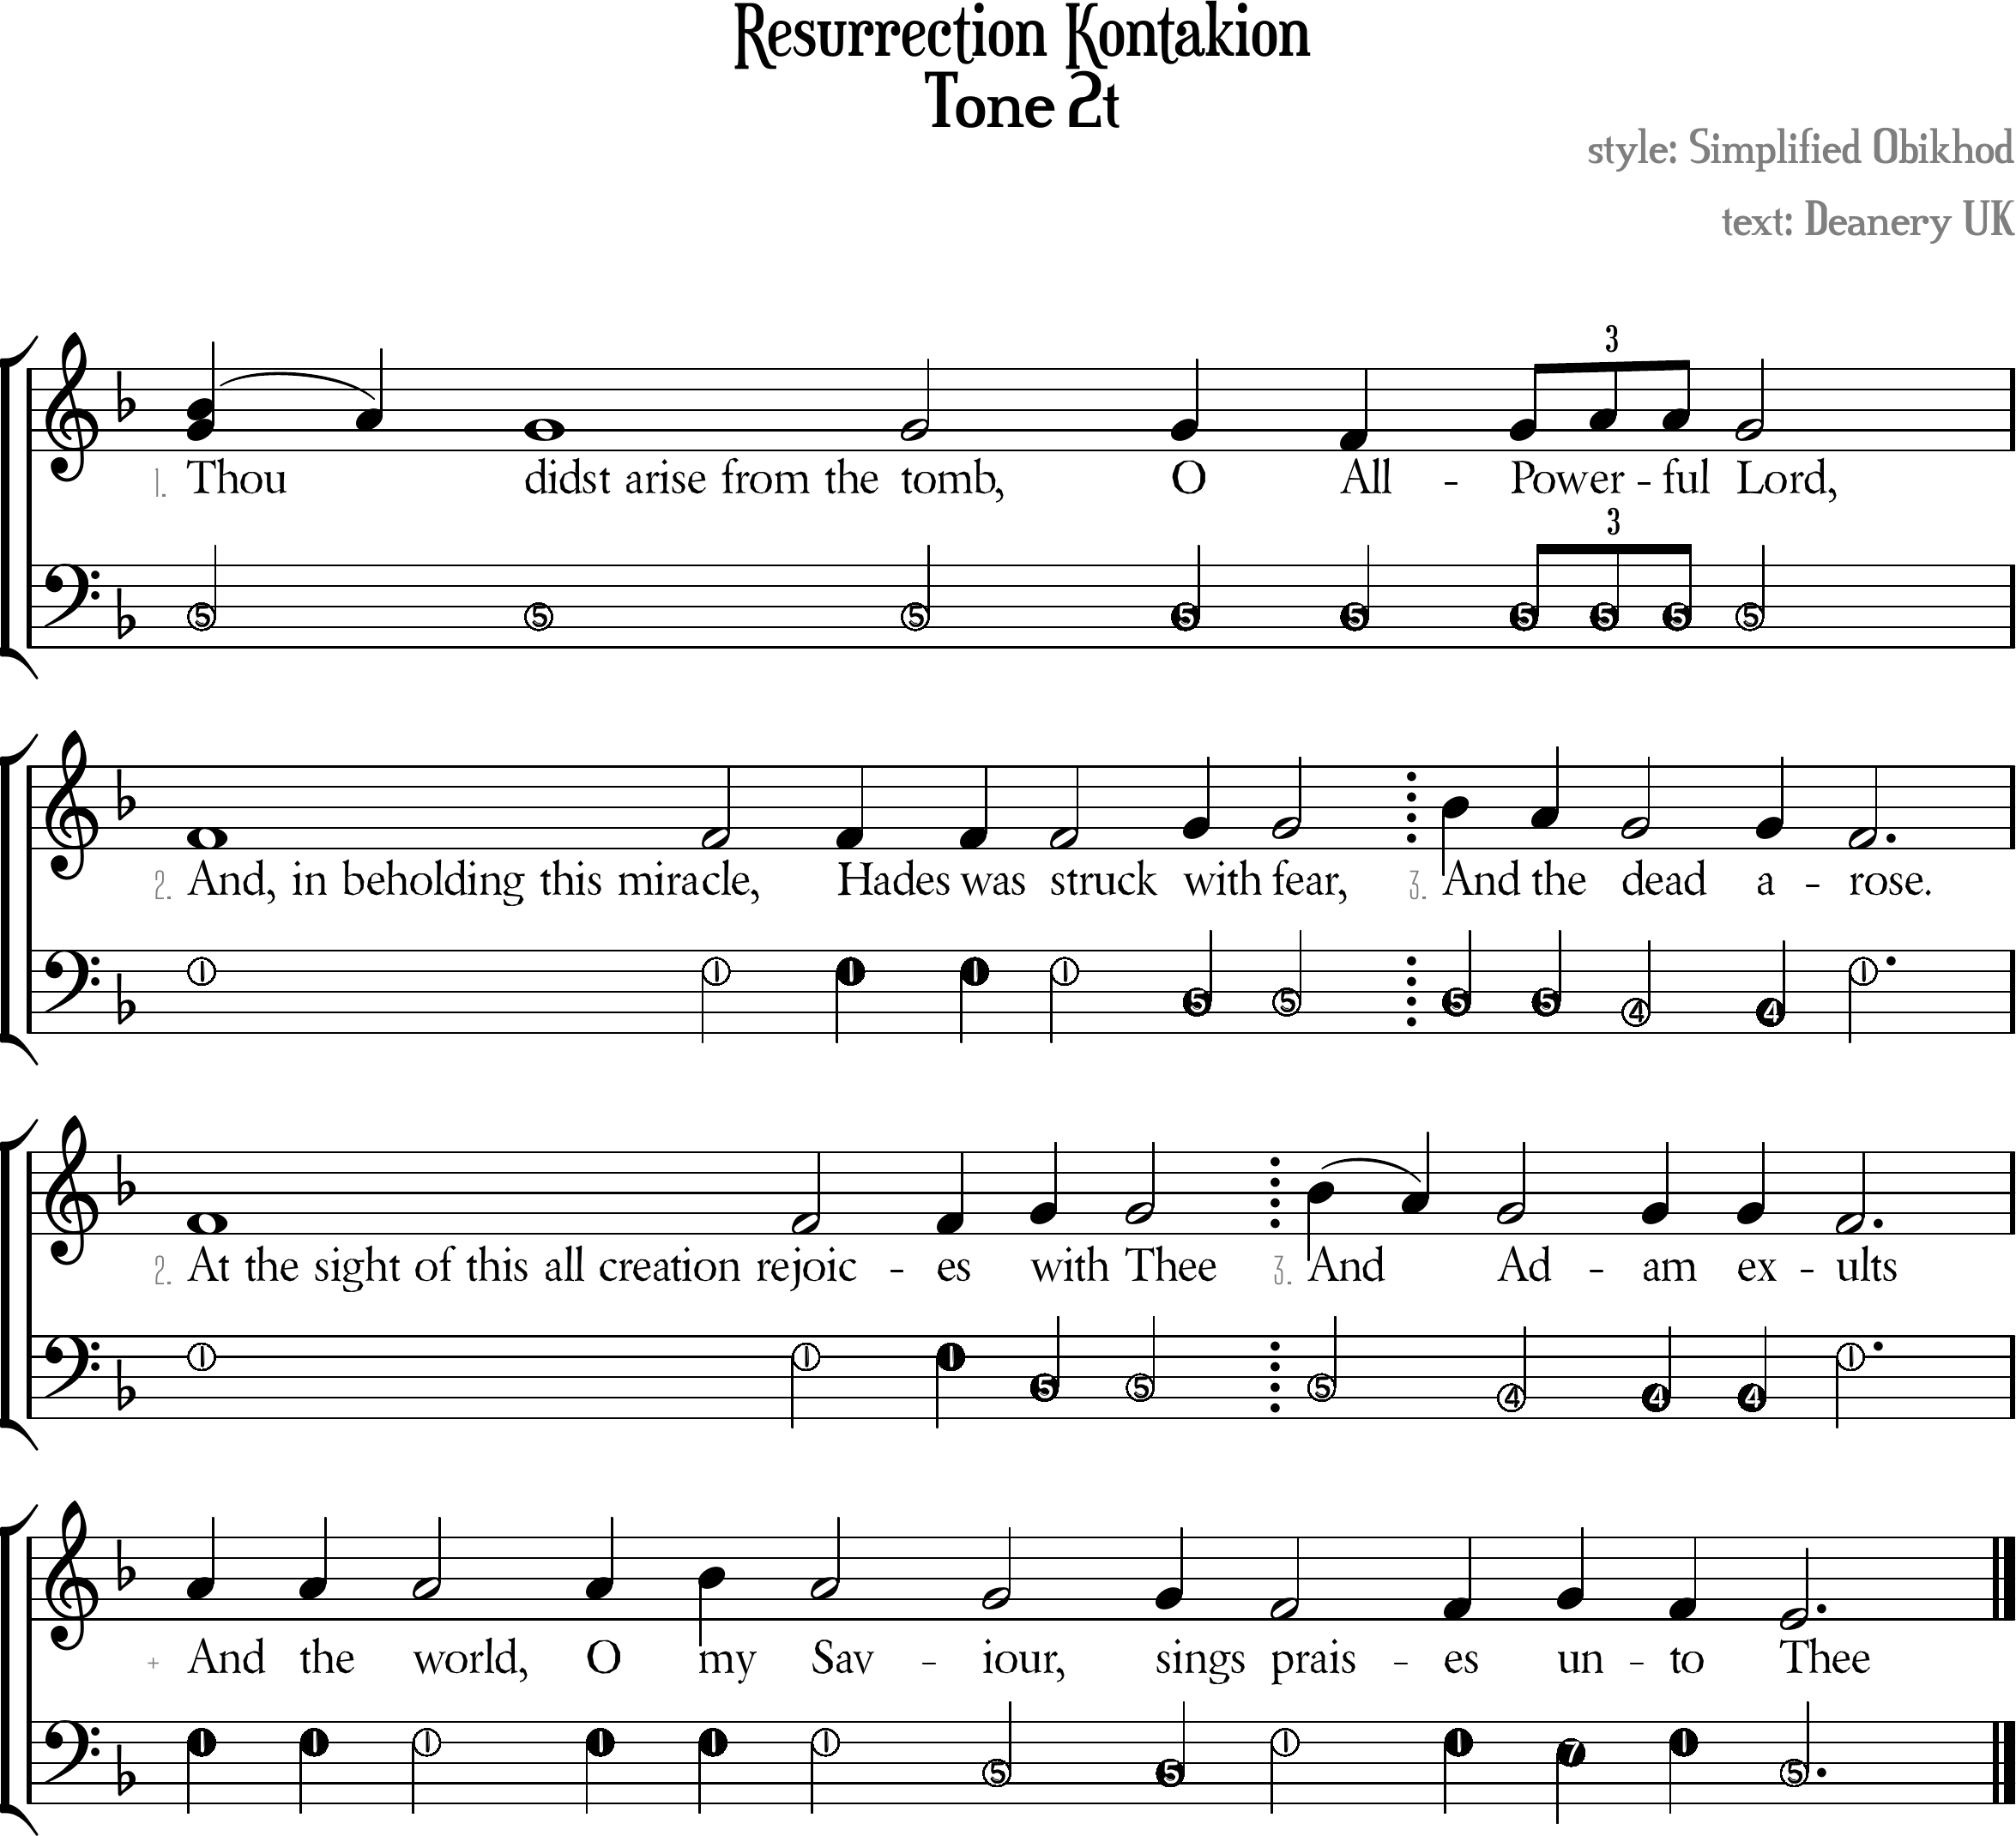

Resurrection Kontakion Tone 2t
[ Tone Pattern ]
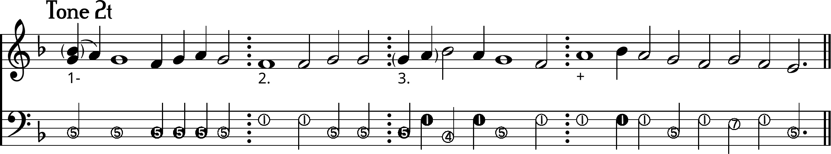
1- | /Thou/~ \didst arise from the tomb,  O \All-/Pow/erful \Lord,
2. | \And, in beholding this miracle,  Hades was struck /with fear,
3. | //And \the \dead a\rose.
2. | At the sight of this all creation rejoic/es with Thee
3. | //A\~nd \Adam e\xults
+ | //And the world, O /my \Sa\viour,  sings \praises /un\to \Thee

[ Ison ]
I- | ⁵Thou didst arise from the tomb, O All-Powerful Lord,
II. | ¹And, in beholding this miracle,  Hades was struck ⁵with fear,
III. | ⁵And the ⁴dead a¹rose.
II. | ¹At the sight of this all creation rejoic⁵es with Thee
III. | ⁵And ⁴Adam e¹xults
+ | ¹And the world, O my Sa⁵viour, sings ¹praises ⁷un¹to ⁵Thee

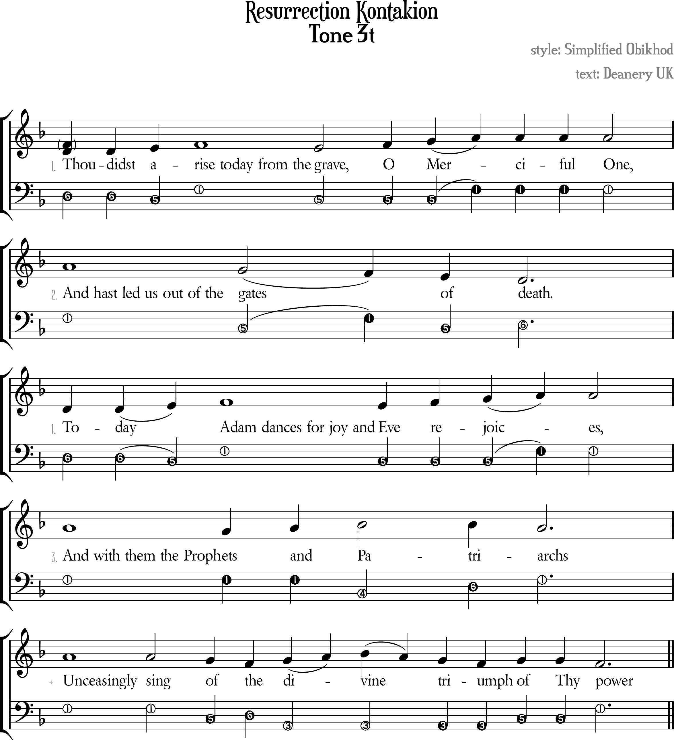

Resurrection Kontakion Tone 3t
[ Tone Pattern ]
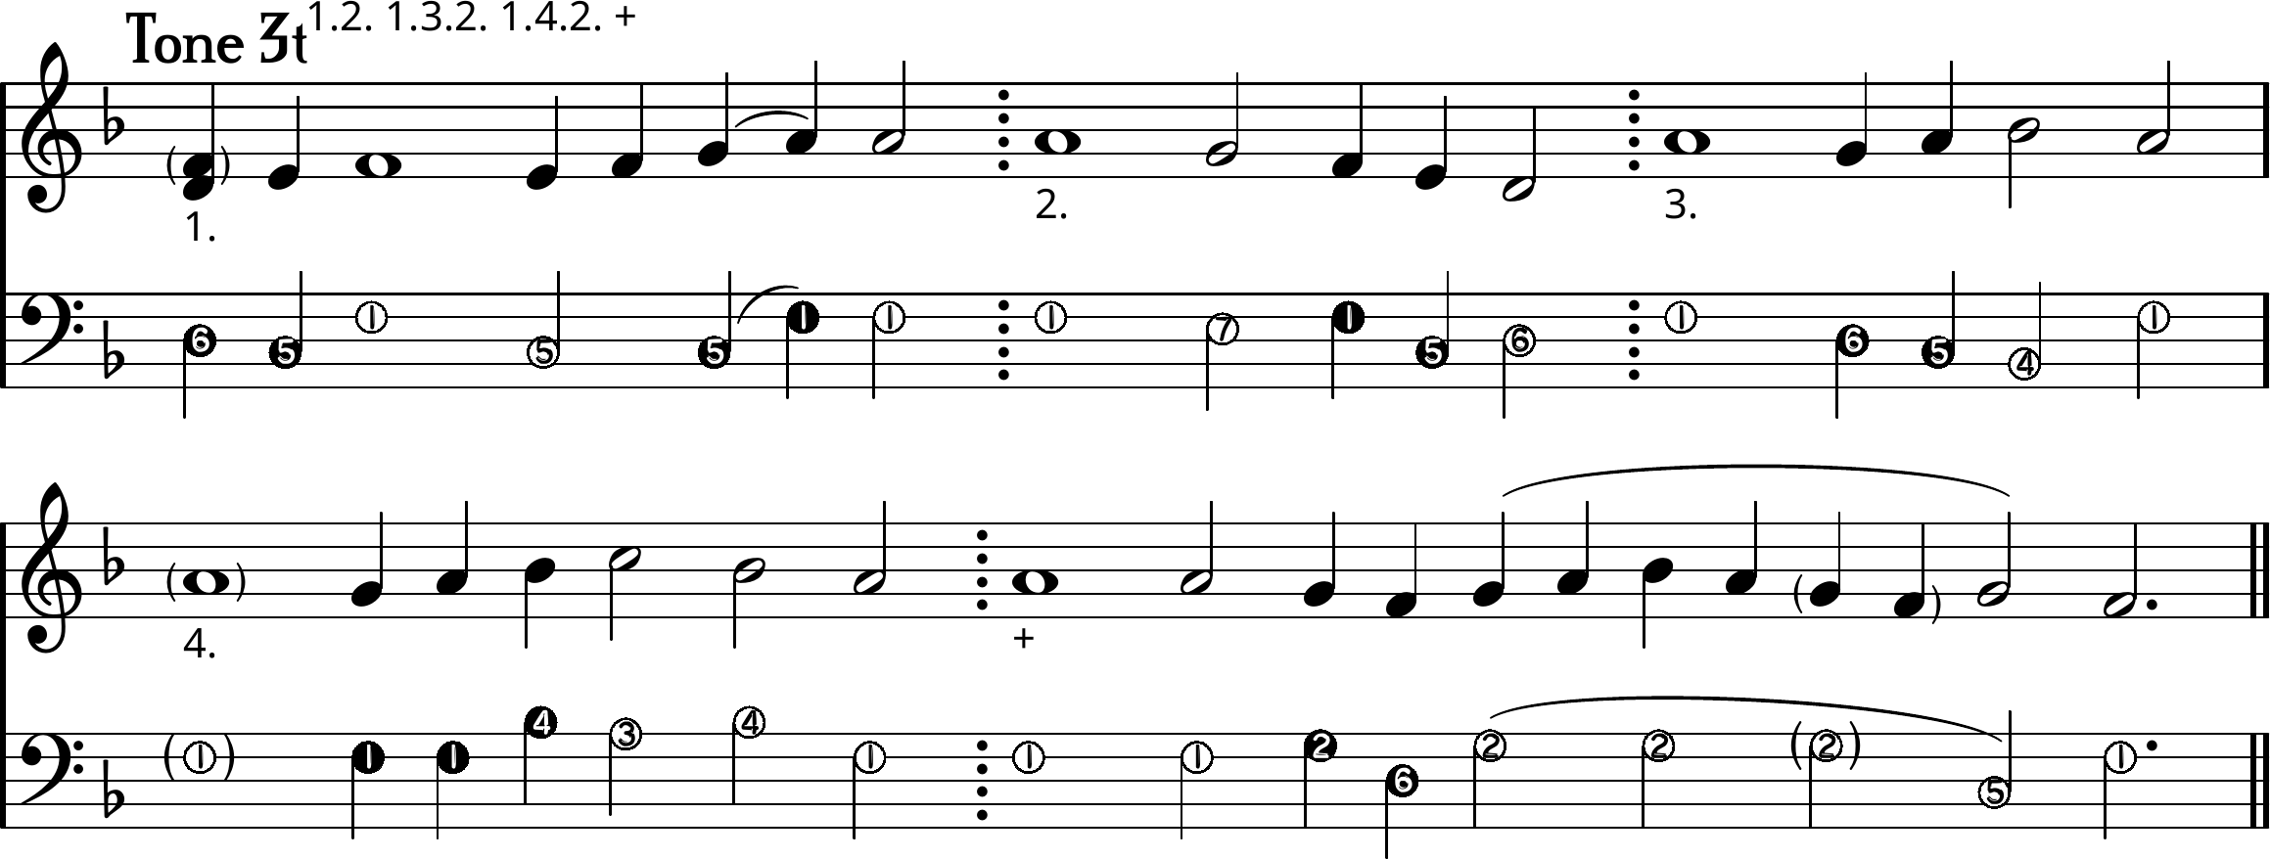

1. | \\Thou didst /a/rise today from the \grave,  /O /Me/~rciful One,
2. | And hast led us out of the \ga\~tes \of \death.
1. | Today/~ /Adam dances for joy and \Eve /re/jo/ices,
3. | And with them the Pro\phets /and /Patri\archs
+ | Unceasingly sing \of \the  /di/~vi/~\ne \tri\umph /of Thy \power

[ Ison ]
I. | ⁶Thou didst ⁵a¹rise today from the ⁵grave,  O Me¹~rciful One,
II. | ¹And hast led us out of the ⁵ga¹~tes ⁵of ⁶death.
I. | ⁶Today⁵~ ¹Adam dances for joy and ⁵Eve rejo¹ices,
III. | ¹And with them the Prophets and ⁴Pa⁶tri¹archs
+ | ¹Unceasingly sing ⁵of ⁶the ³divine triumph ⁵of Thy ¹power

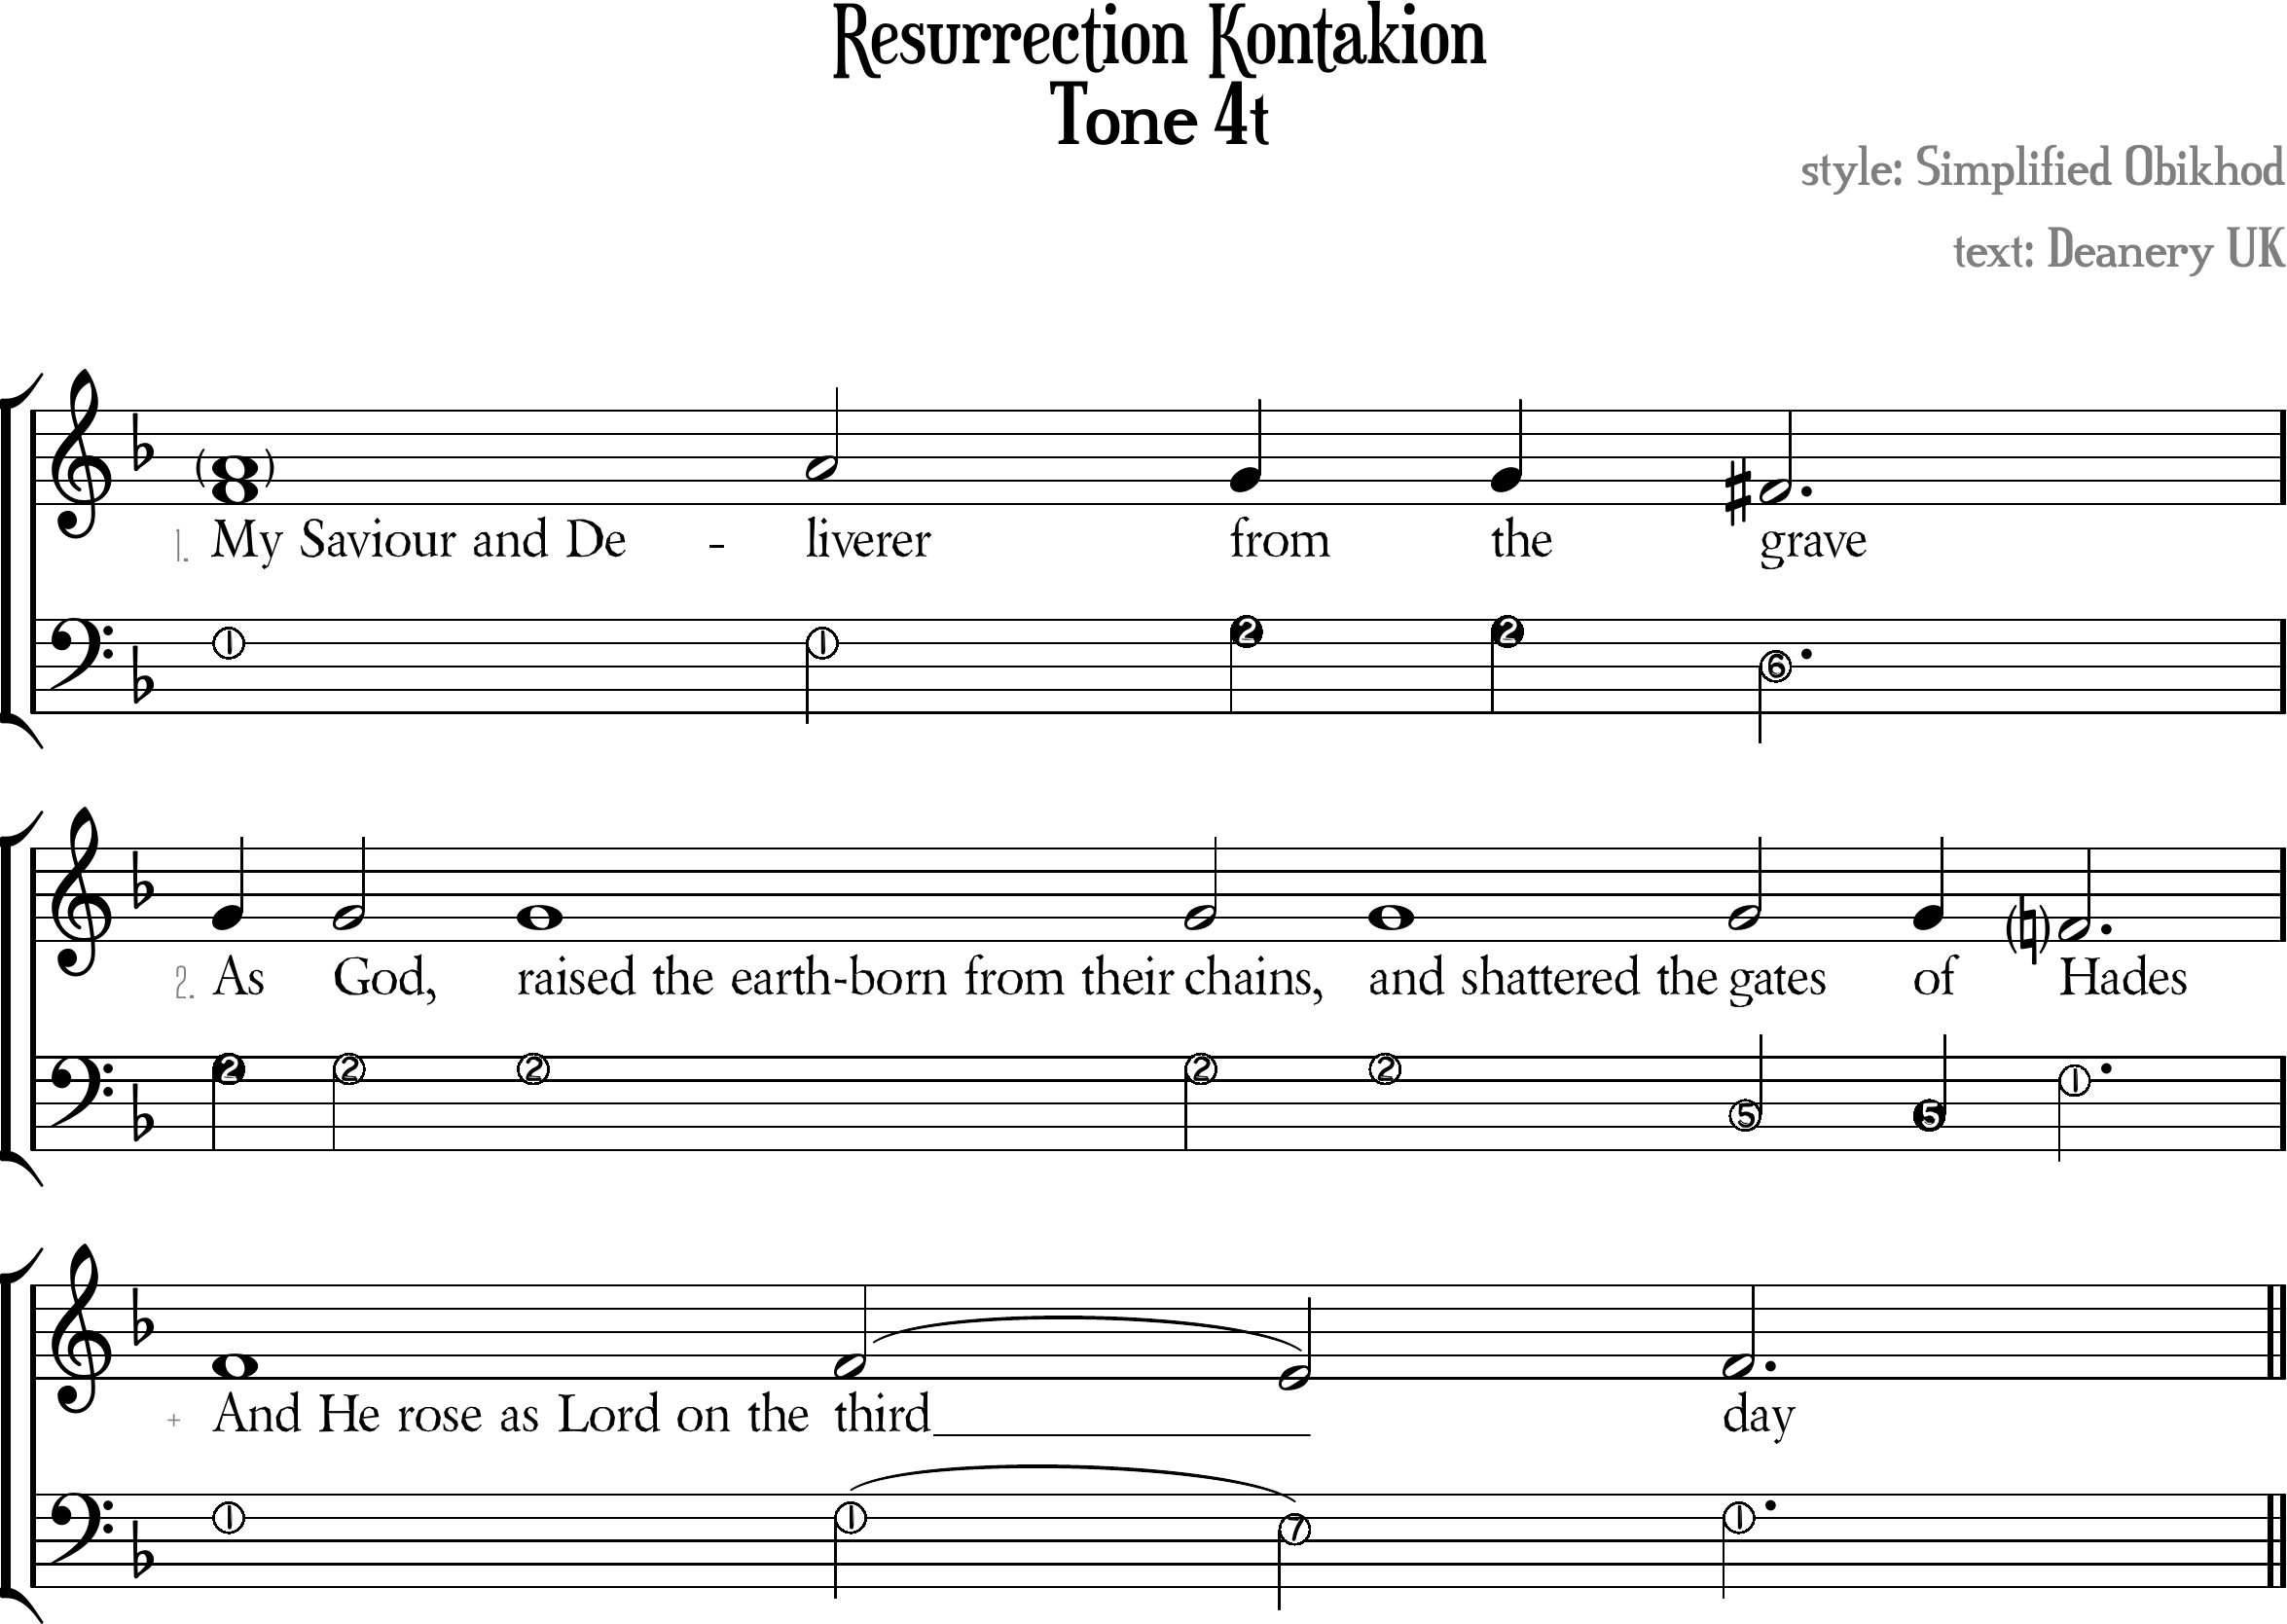

Resurrection Kontakion Tone 4t
[ Tone Pattern ]
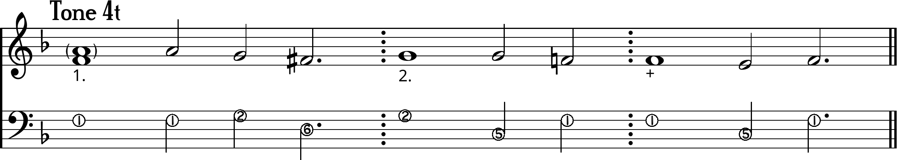

1. | My Saviour and De//liverer \from the \♯grave
2. | /As God, raised the earth-born from their chains,  and shattered the gates of \Hades
+ | And He rose as Lord on the thi\~rd /day

[ Ison ]
I. | ¹My Saviour and Deliverer ²from the ⁶grave
II. | ²As God, raised the earth-born from their chains,  and shattered the ⁵gates of ¹Hades
+ | ¹And He rose as Lord on the thi⁵~rd ¹day

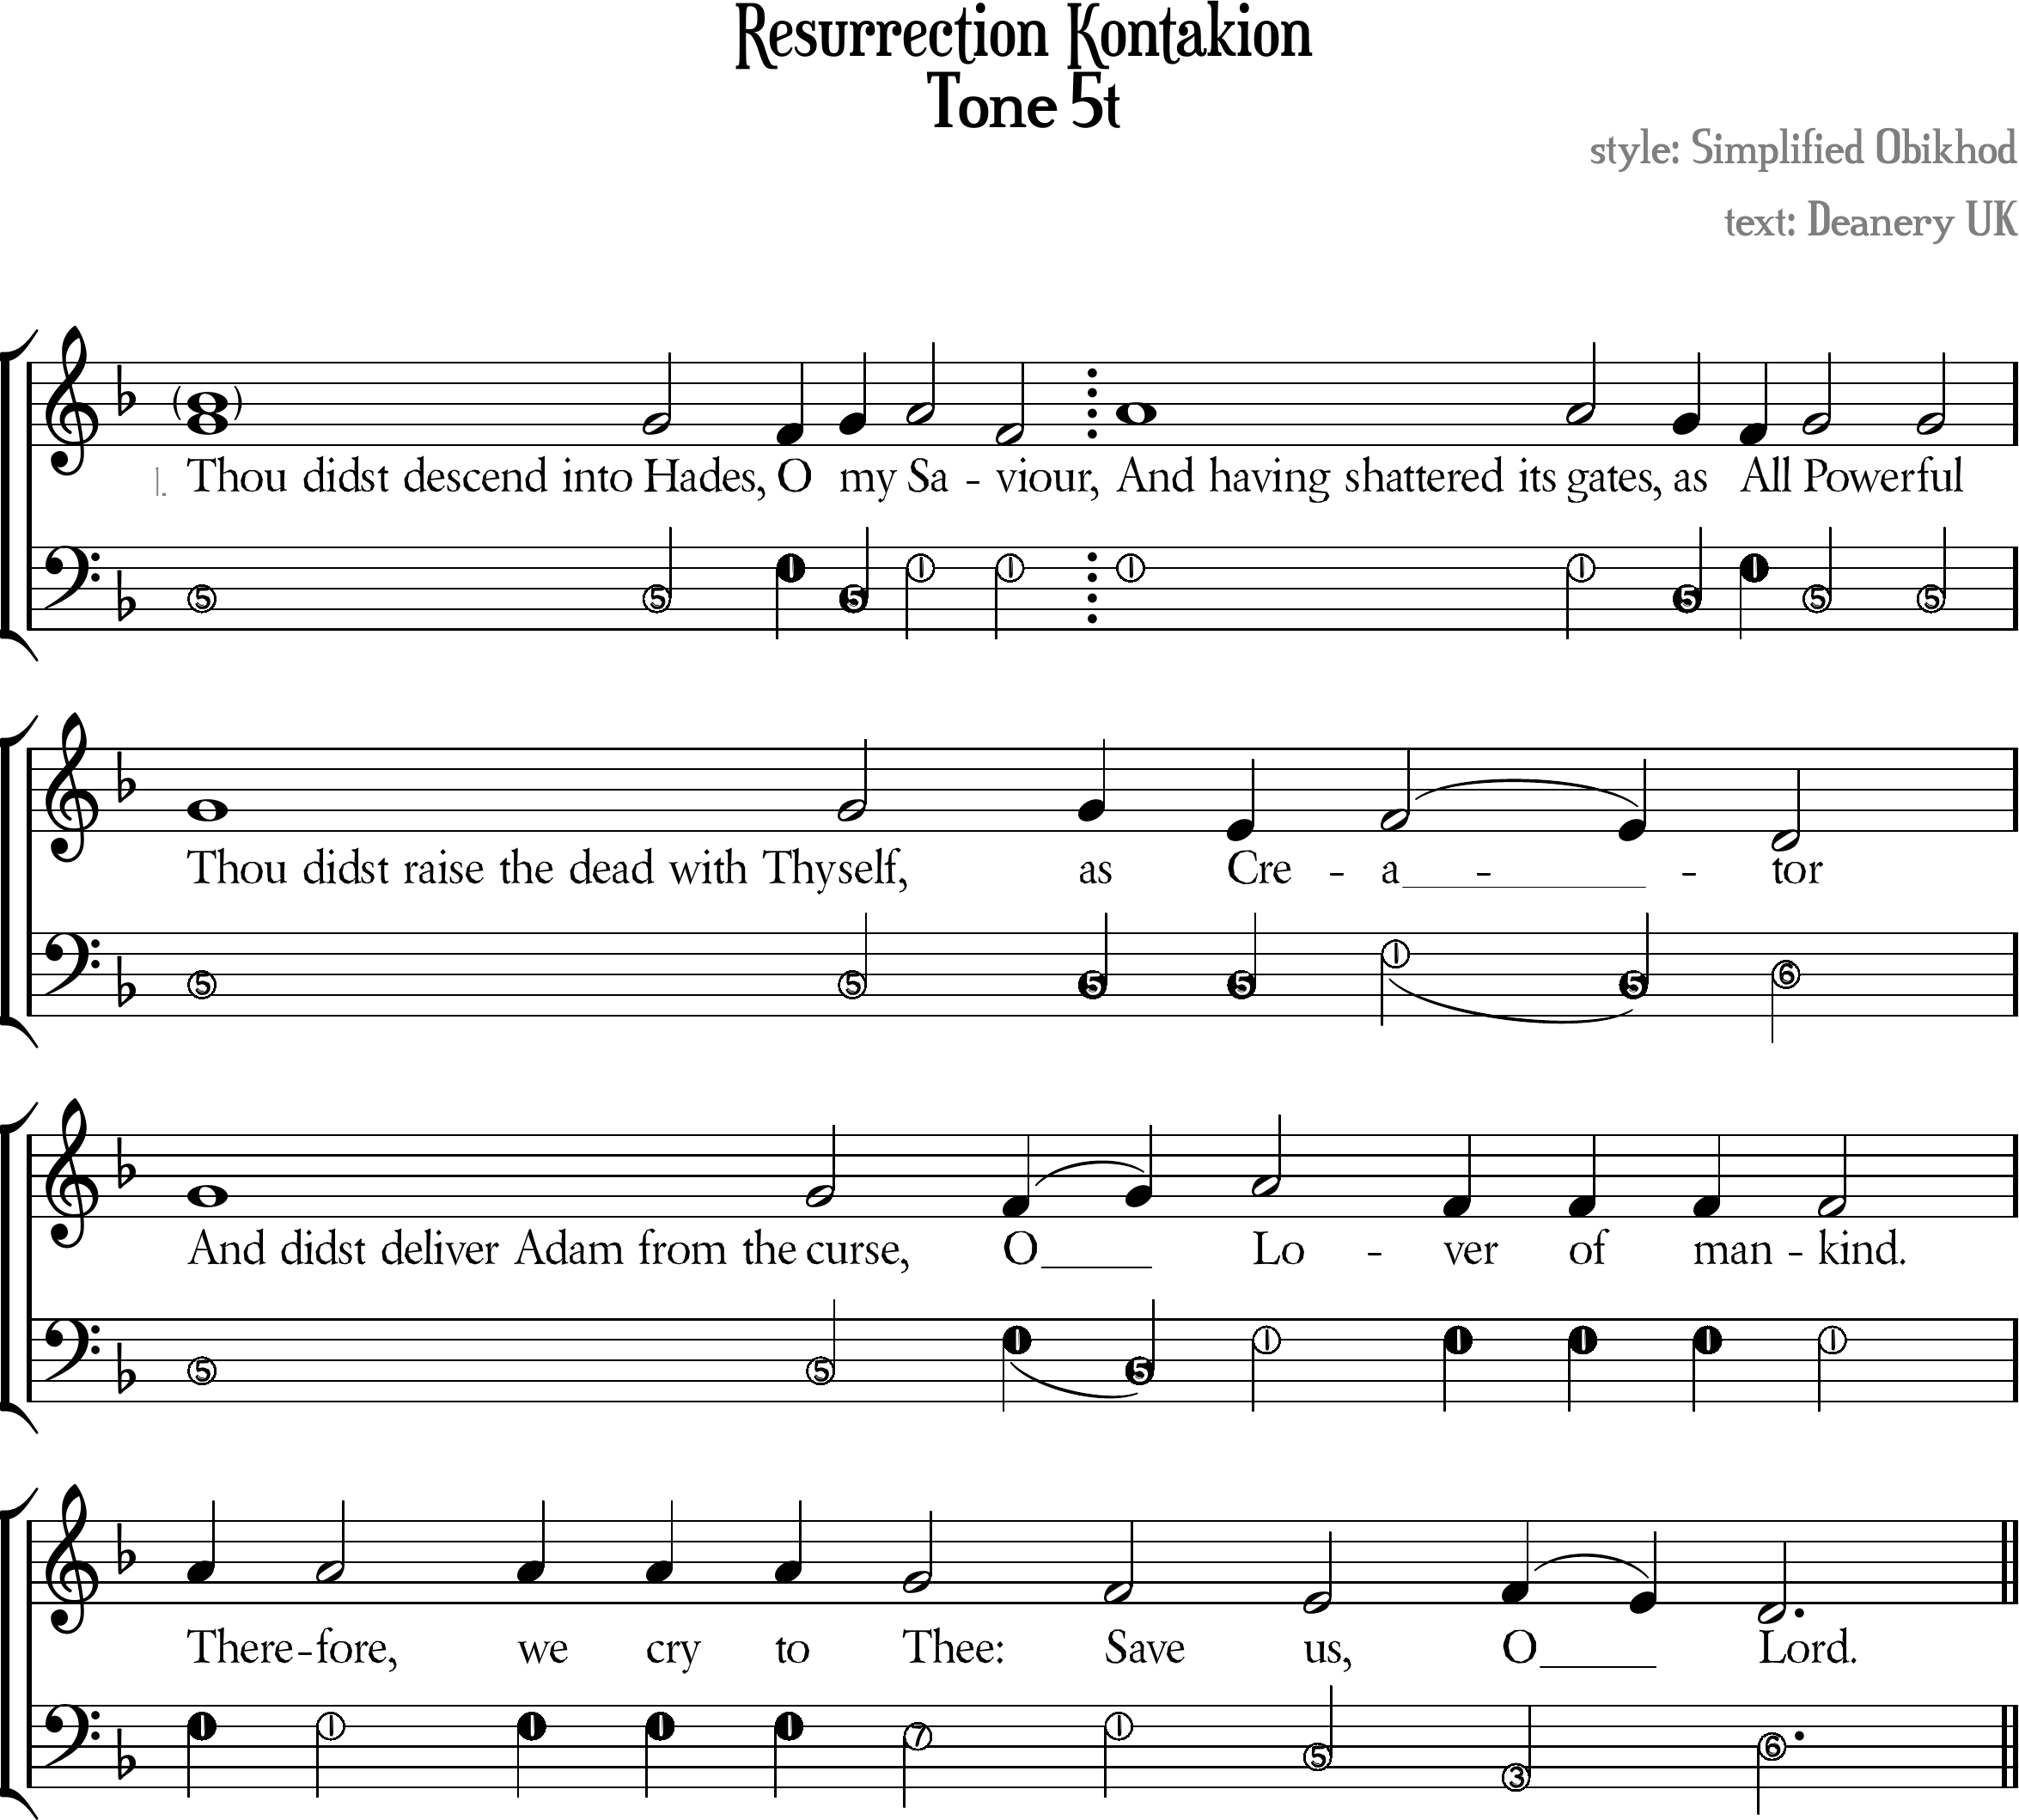

Resurrection Kontakion Tone 5t
[ Tone Pattern ]
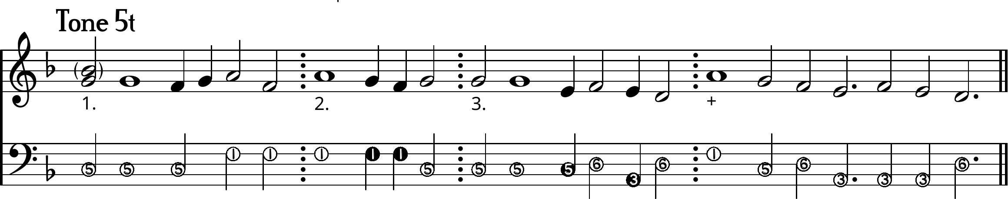

1. | /Thou didst descend into Hades, \O /my /Sa\\viour,
2. | //And having shattered its gates, \as \All /Powerful
3. | Thou didst raise the dead with Thyself, as \\Cre/a\~\tor
1. | ///And didst deliver Adam from the curse,  \O/~ /Lo\\ver of mankind.
+ | //Therefore, we cry to \Thee: \Save \us, /O\~ \Lord.

[ Ison ]
I. | ⁵Thou didst descend into Hades, ¹O ⁵my ¹Saviour,
II. | ¹And having shattered its gates, ⁵as ¹All ⁵Powerful
III. | ⁵Thou didst raise the dead with Thyself, as Cre¹a⁵~⁶tor
I. | ⁵And didst deliver Adam from the curse,  ¹O⁵~ ¹Lover of mankind.
+ | ¹Therefore, we cry to ⁷Thee: ¹Save ⁵us, ³O ⁶Lord.

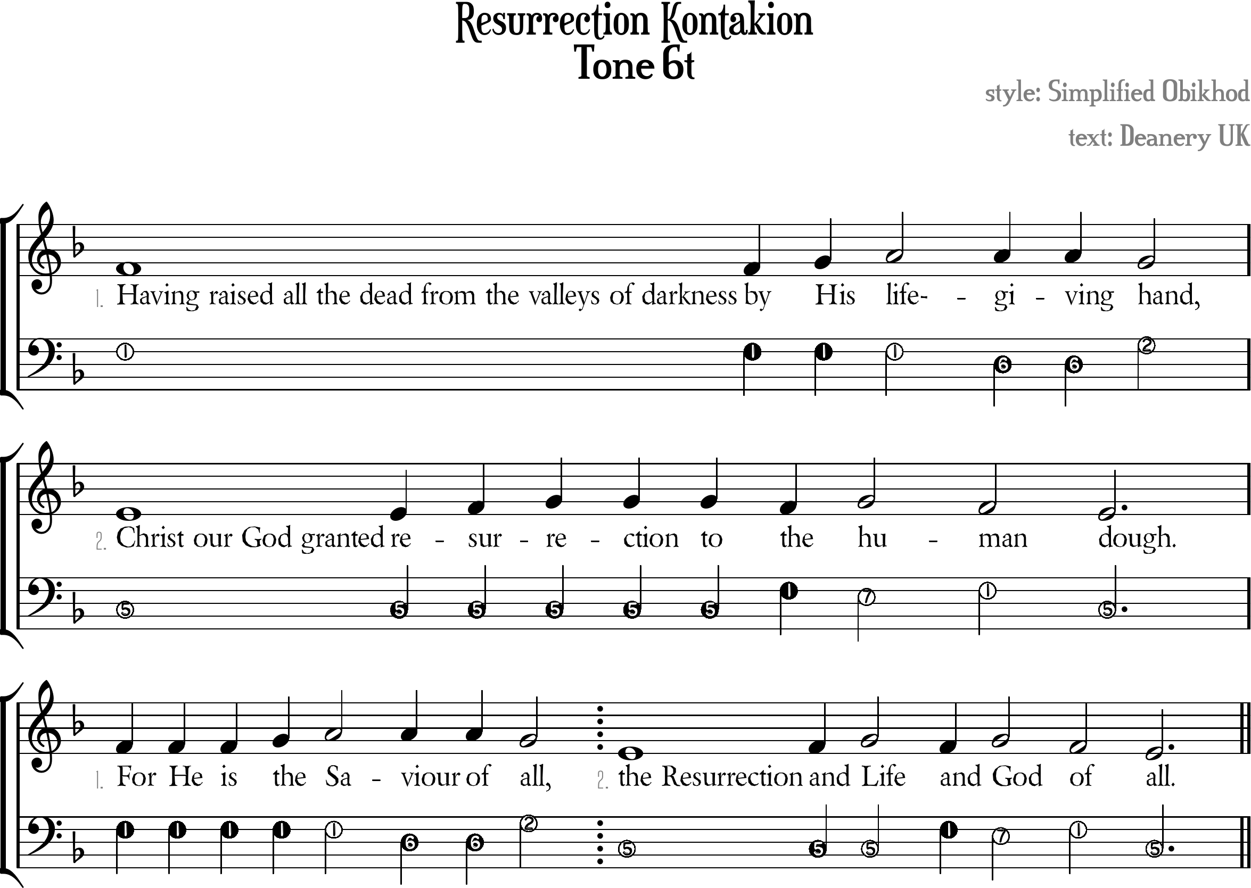

Resurrection Kontakion Tone ⁶t
[ Tone Pattern ]
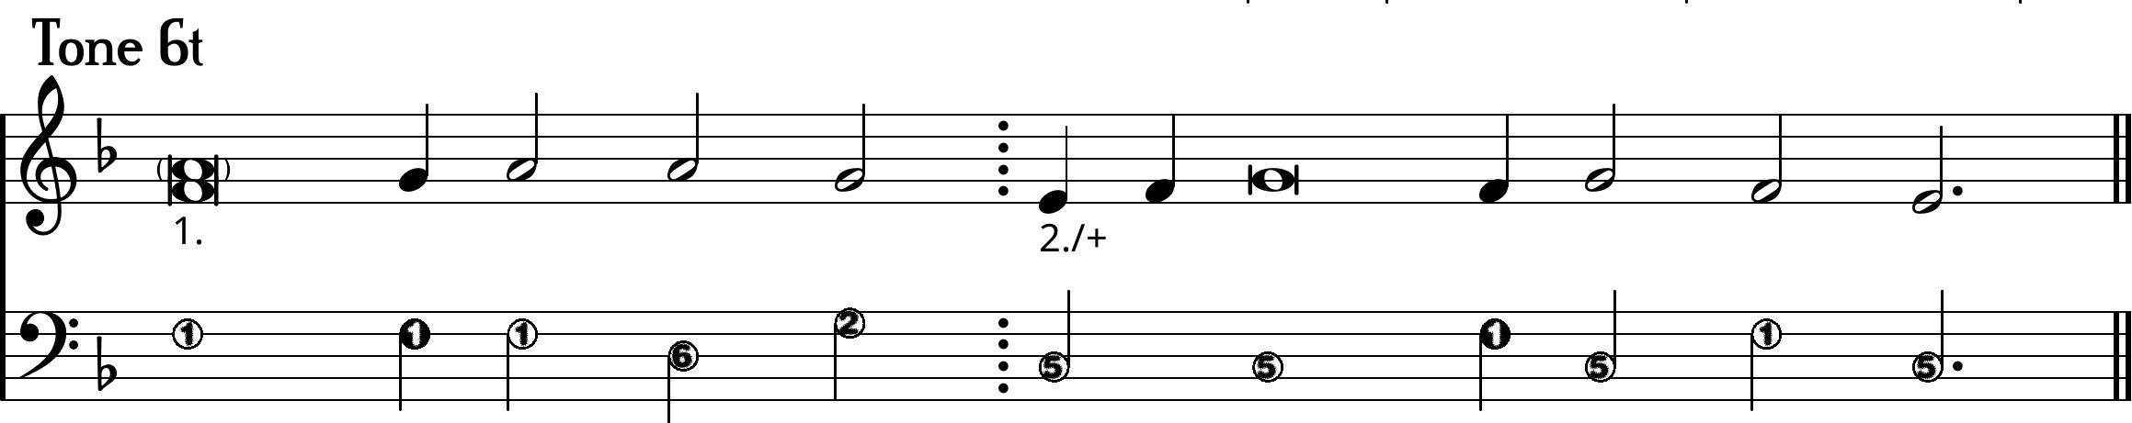

1. | Having raised all the dead from the valleys of darkness  by /His /life-giving \hand,
2. | \\Christ our God granted re/sur/rection  to \the /hu\man \dough.
1. | /For He is /the /Saviour of \all,
2+ | \\The Resurrection /and /Life \and /God \of \all.

[ Ison ]
I. | ¹Having raised all the dead from the valleys of darkness  by His life-⁶giving ²hand,
II. | ⁵Christ our God granted resurrection  to ¹the ⁷hu¹man ⁵dough.
I. | ¹For He is the Sa⁶viour of ²all,
II+ | ⁵The Resurrection and Life ¹and ⁷God ¹of ⁵all.

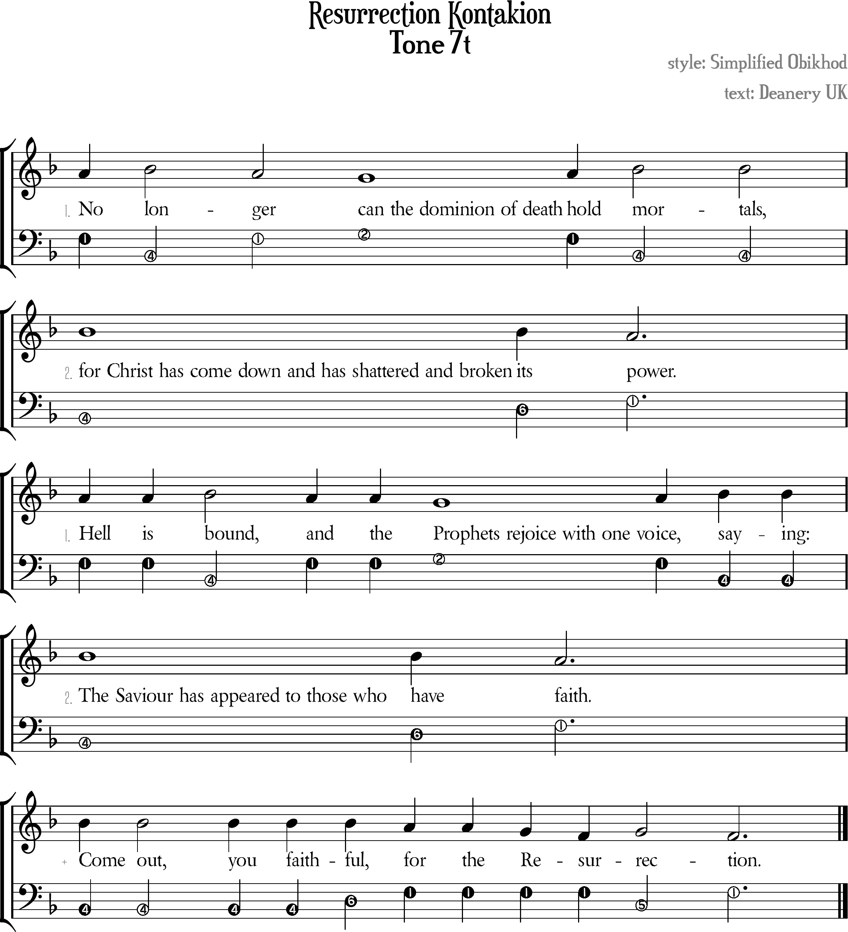

Resurrection Kontakion Tone 7t
[ Tone Pattern ]
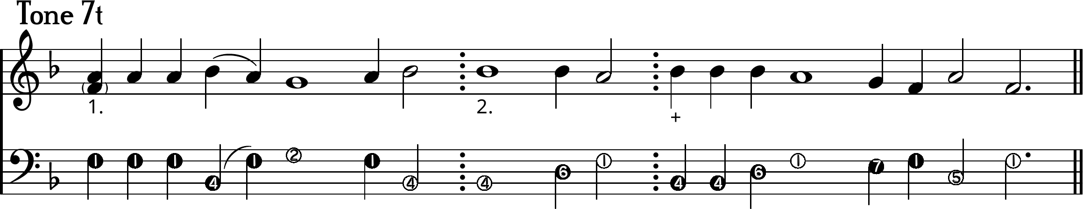

1. | //No /lon\ger \can the dominion of death  /hold /mortals,
2. | For Christ has come down and has shattered  and broken its \power.
1. | Hell is /bound, \and the  \Prophets rejoice with one vo/ice, /saying:
2. | The Saviour has appeared to those who have \faith.
+ | /Come out, you faithful \for the \Re\sur/rec\tion.

I. | ¹No ⁵lon¹ger ²can the dominion of death  ¹hold ⁴mortals,
II. | ⁴For Christ has come down and has shattered  and broken ⁶its ¹power.
I. | ¹Hell is ⁴bound, ¹and the  ²Prophets rejoice with one vo¹ice, ⁴saying:
II. | ⁴The Saviour has appeared to those who ⁶have ¹faith.
+ | ⁴Come out, you faith⁶ful ¹for the Resur⁵rec¹tion.

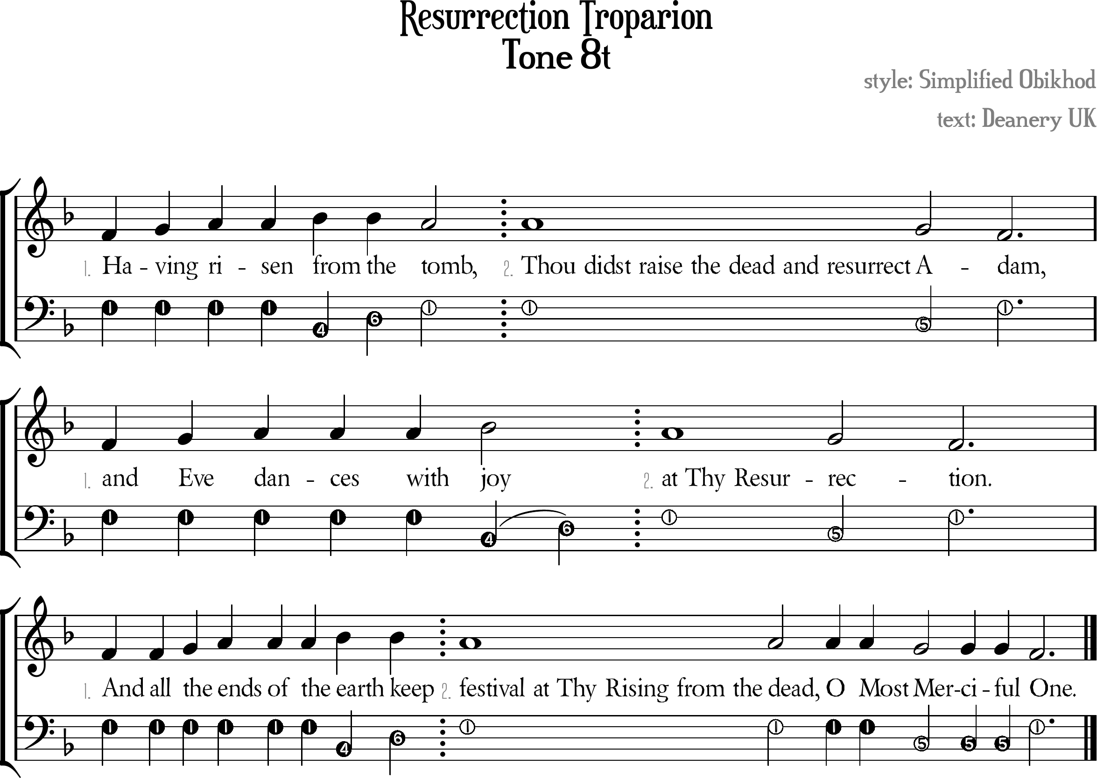

Resurrection Kontakion Tone 8t
[ Melody/Ison Template ]
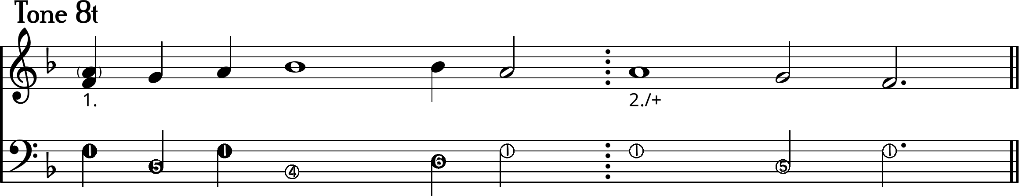

1. | Ha/ving /risen /from the \tomb,
2. | Thou didst raise the dead and resurrect \A\dam,
1. | And /Eve /dances with /joy
2. | \At Thy Resur\rec\tion.
1. | And all /the /ends of the /earth keep
2+ | \Festival at Thy Rising from the dead,  O Most \Merciful \One.

I. | ¹Having risen ⁴from ⁶the ¹tomb,
II. | ¹Thou didst raise the dead and resurrect ⁵A¹dam,
I. | ¹And Eve dances with ⁴jo⁶~y
II. | ¹At Thy Resur⁵rec¹tion.
I. | ¹And all the ends of the ⁴earth ⁶keep
II+ | ¹Festival at Thy Rising from the dead,  O Most ⁵Merciful ¹One.

